IB Geography – What constitutes a technological hazard?
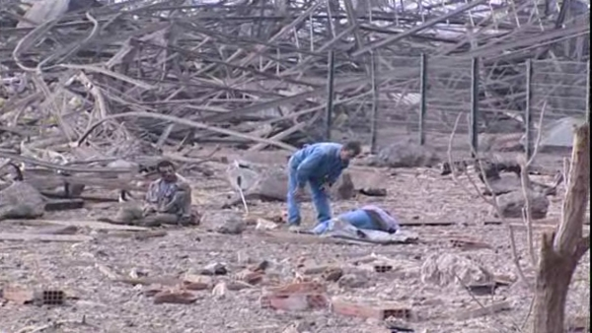
The following are a list of types of ‘human induced’ or technological hazards.
- release of chemicals to the atmosphere by explosion, fire
- release of chemicals into water (groundwater, rivers etc.) by tank rupture, pipeline rupture,
chemicals dissolved in water (fire),
- oil spills in marine environment
- satellite crash (radionuclides)
- radioactive sources in metallurgical processes
- other sources of releases of radionuclides to the environment
- contamination by waste management activities
- soil contamination
- accidents with groundwater contamination (road, rail)
- groundwater contamination by waste dumps (slowly moving contamination)
- aircraft accidents
- releases and contaminations as a consequence of military actions (e.g. depleted uranium), or
destruction of facilities
- releases as consequence of the industrial use of biological material (e.g. viruses, bacteria, fungi)

