IB Geography Hazards – Drought Hazard

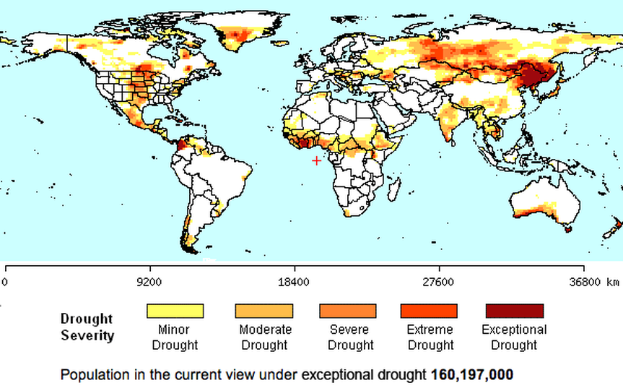
Above is a map of the world showing the spatial distribution of drought events.
Task 1 - Comment on the global distribution of extreme and exceptional drought events.

Task 2 – Link to Patterns & Change – Identify two areas on the map that have high population densities or overall populations and also suffer from the drought hazard.

Why do droughts occur? 1. Shifting ITCZ
The ITCZ can shift in position (see map below) depending on the movement of the overhead sun thus, locations that lie within this fluctuating zone will experience wet and dry seasons with rainfall lasting for 5 to 6 months a year on average. The dry seasons will tend to occur with the period where the sub-tropical high-pressure belts lies across a particular area (20-30° North and South) due to the shifting of the ITCZ. This area will experience high pressure which prevents the formation of rain clouds thus, leading to the formation of deserts. The size of these areas will also vary from year to year and in years where the areas are larger, droughts along the desert edges will occur.

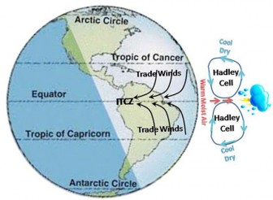
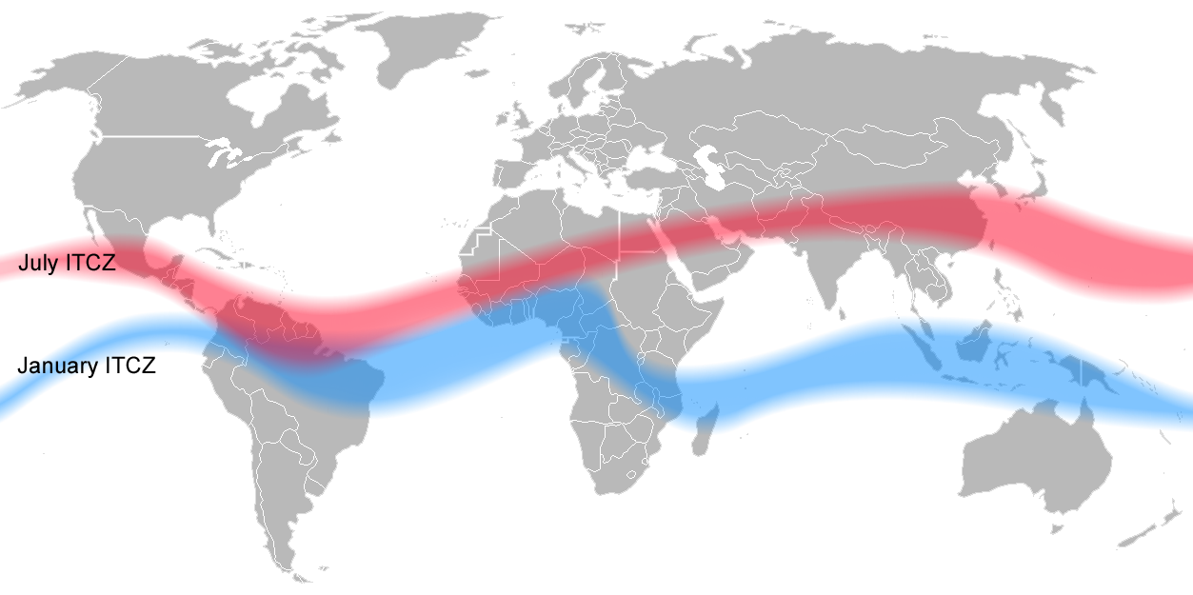

Why do droughts occur? 2. El Nino
El Nino is the term used to describe an extensive warming of the upper ocean in the tropical eastern Pacific lasting up to a year or even more. They are normally linked with a change in atmospheric pressure known as the Southern Oscillation (SO).Under normal atmospheric conditions, pressure rises over the eastern Pacific Ocean and falls over the western Pacific Ocean. This creates a circulation system where the upper air moves from west to east and the surface air from east to west as the trade winds. During El Nino, there is a reversal in these conditions and this allows the ITCZ to migrate southwards and causes the trade winds to weaken in strength or even to be reversed in direction. The air will now descend over South East Asia instead of the eastern pacific, giving us much drier conditions and even droughts at times.

Task 3 – Find an image that you understand that represents the text above and paste it into the space below with a reference.

Why do droughts occur? – 3. Global Warming
Global warming is the result of the escalation of the greenhouse effect and rising global temperatures. This may cause climate boundaries to shift their positions, making some regions wetter while others become drier and it may also cause the frequency of El Nino to increase, which will worsen drought conditions.

Why do droughts occur? – 4. Population Growth
A rise in population densities will cause droughts as the population far outstrips food production. The rise in demand leads to the progressive conversion of natural ecosystems into farmland which has given rise to desertification when the cropland are over cultivated, fallow seasons are shortening and mismanagement of irrigated croplands. Desertification is the permanent transformation of the land surface by human activities to resemble a desert. An example would be the Sahel Region at the edge of the Sahara Desert where the annual precipitation is only 250-500mm.

In Summary
Thus, as we can see, a combination of anthropogenic factors and natural factors are responsible for causing droughts to occur and worsen over the years.

