IB Geography – Prediciting Droughts
We know that drought have medium to long term speeds of onset and are not immediate hazards like earthquakes. However, with advances in meteorology, can we predict this onset and warn vulnerable populations? Watch the two videos on geographypods and then click on the link and read the text before filling in the table below.

Element | Possibility of prediction
Time of drought
Date of drought | An official drought may be declared on one particular date but there are too many variables to predict what that date might be in the future.
Exact location of drought | One way of predicting drought is to use weather records to forecast two fundamental meteorological variables: precipitation and temperature. The historical occurrence of drought will provide a better basis for us to make informed decisions.
Continent where the drought occurs
The magnitude of the drought | The PSDI is the most effective index in place currently in determining long term drought **How does this scale work**
The economic impact of the drought | UN-sponsored Global Information and Early Warning System (GIEWS) and the USA-sponsored Famine Early Warning System (FEWS NET)  **When & why were these developed?**
The likely death toll of the drought | Due to droughts being classified as a ‘creeping phenomenon’, vulnerable populations may be moved out of harm’s way in theory. However, political and physical factors can prohibit this and so although death total should be low, some factors can exacerbate the death toll although prediction is difficult.

Earthquake Frequency – Making Sense of the patterns
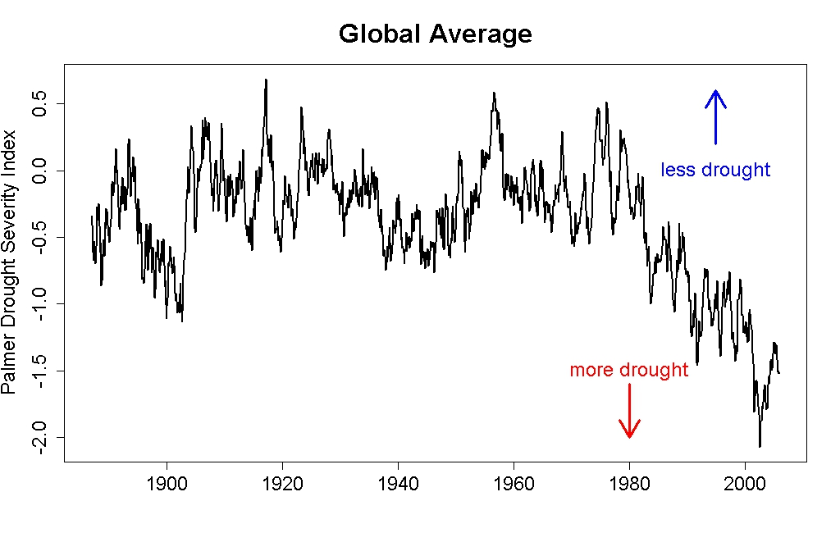

- Study the graph above and comment on the trend of drought globally

- Describe the patterns shown in the graph above.

- Global world population started exploding in the 1950’s (remember the graph?). Is there a relationship between both sets of data?

Future Frequency of Drought Hazards
Read the information on the link found on geographypods and then summarise in three key points below the likely frequency and locations of future drought events:

Causes (physical & human):

Locations:

Vulnerable Populations:

