IB DP Geography – Single Index Measurements
Task. IB ask us to do the following: Define and examine the spatial distribution of indices of infant mortality, education, nutrition, income and explain the value of these indices in measuring global disparities.
So, below you will find maps that cover the following single index measurements.
- Infant mortality rate (per 1,000 live births)
- Government expenditure on education (% of GDP)
- Stunting (moderate or severe) (% under age 5)
- Gross domestic product (GDP) per capita (2011 PPP $)
You need to decide which map represents each of the single index indicators above. Look carefully for clues and think about what you have learnt previously in the Populations in Transition Unit.
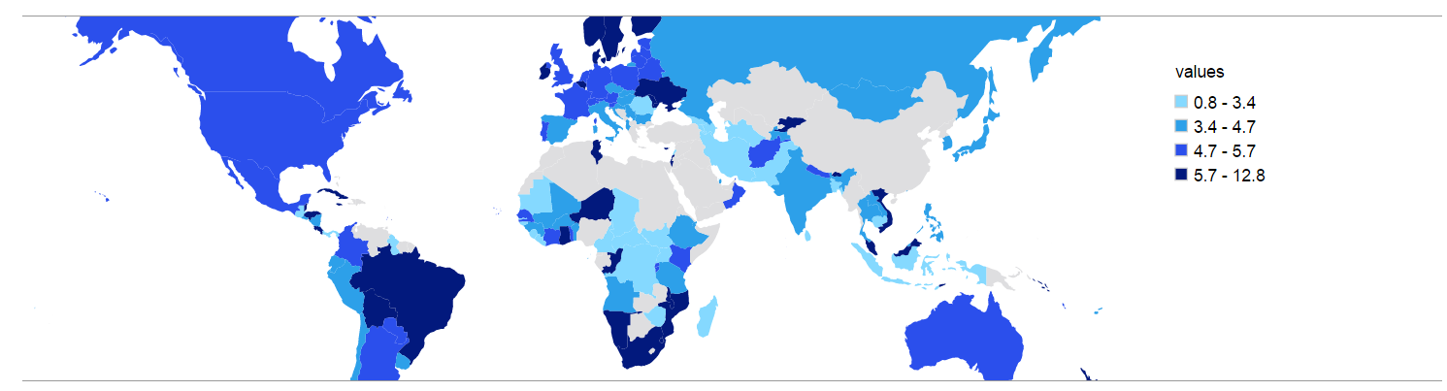
Map 1: Title:

Describe the spatial distribution of the index on the map above.

Explain this distribution

Identify one advantage of using this index as a measure of disparity.

Identify one disadvantage of using this index as a measure of disparity

Map 2 Title:
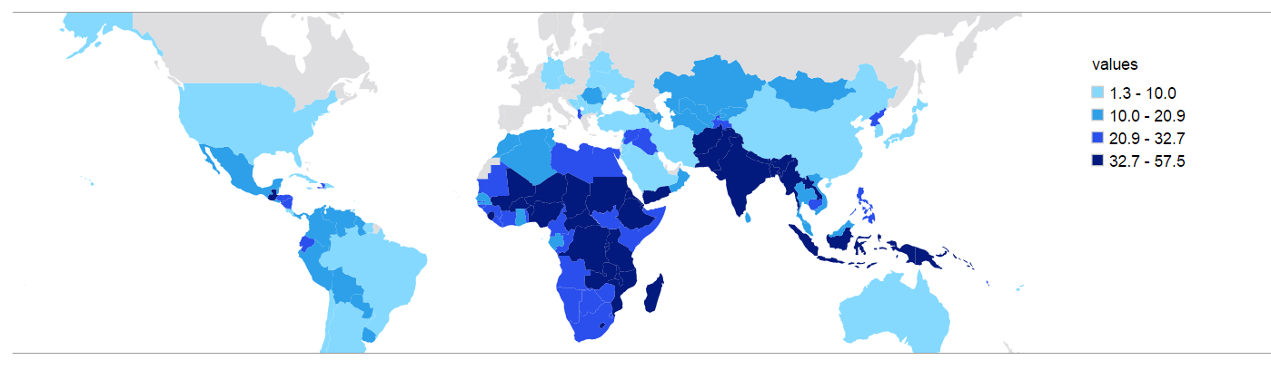

Describe the spatial distribution of the index on the map above.

Explain this distribution

Identify one advantage of using this index as a measure of disparity.

Identify one disadvantage of using this index as a measure of disparity

Map 3 Title:

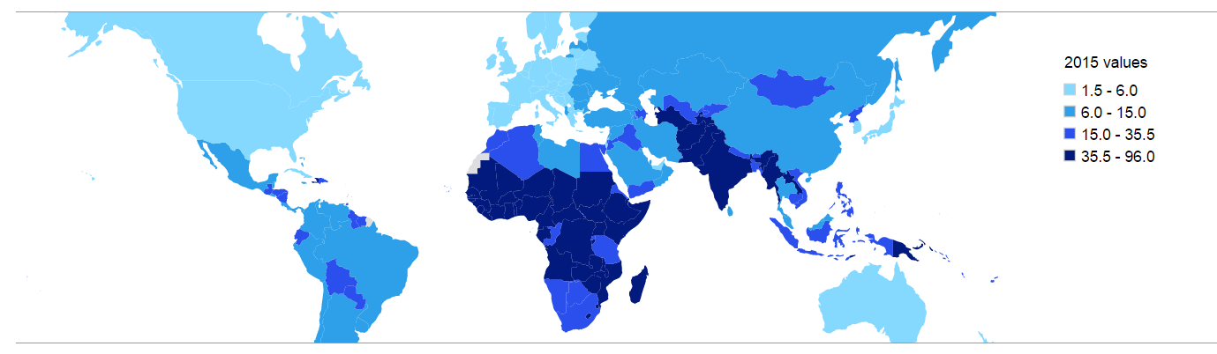

Describe the spatial distribution of the index on the map above.

Explain this distribution

Identify one advantage of using this index as a measure of disparity.

Identify one disadvantage of using this index as a measure of disparity

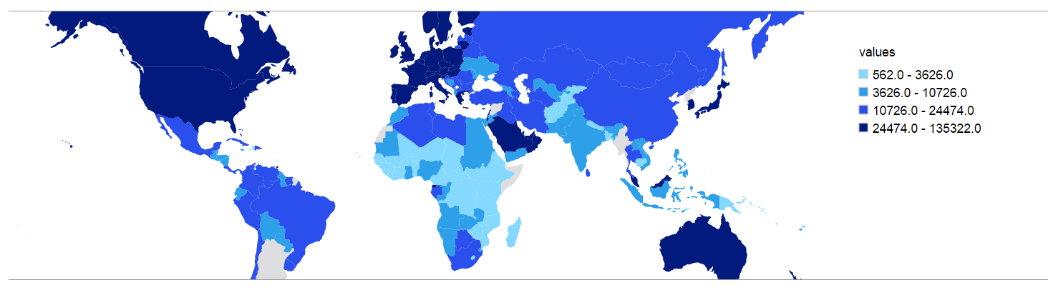
Map 4 Title:

Describe the spatial distribution of the index on the map above.

Explain this distribution

Identify one advantage of using this index as a measure of disparity.

Identify one disadvantage of using this index as a measure of disparity

 | IMR / 1000 /yr | Education % of GDP | Stunting % | GDP PPP $
China
USA
Australia
Brazil
Niger
France

Exam Corner: Examples of past questions linking to this syllabus point:

Suggest two reasons why GDP per person is not a reliable way of measuring
global disparities. [2+2]

Further Notes for Final Exam Revision

