IB DP Geography – Composite Measurement Index - HDI
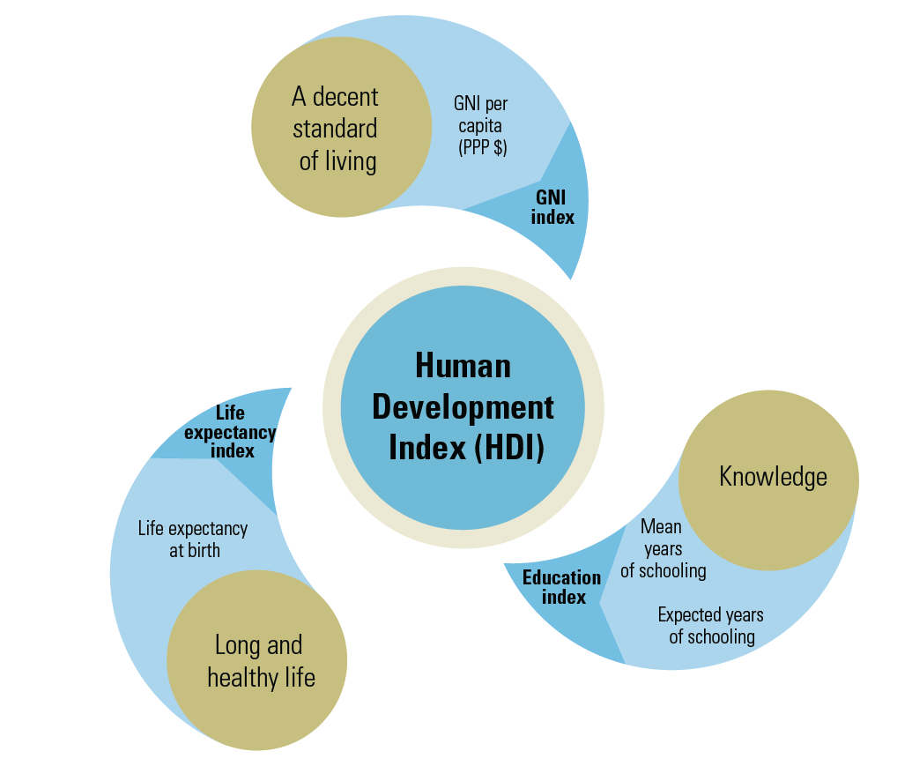
Task 1a – What does human development mean (podcast activity)

Task 1b – Define the Human Development Index, how it is measured and when and why it was created.

Task 2 - What are the limitations of HDI?

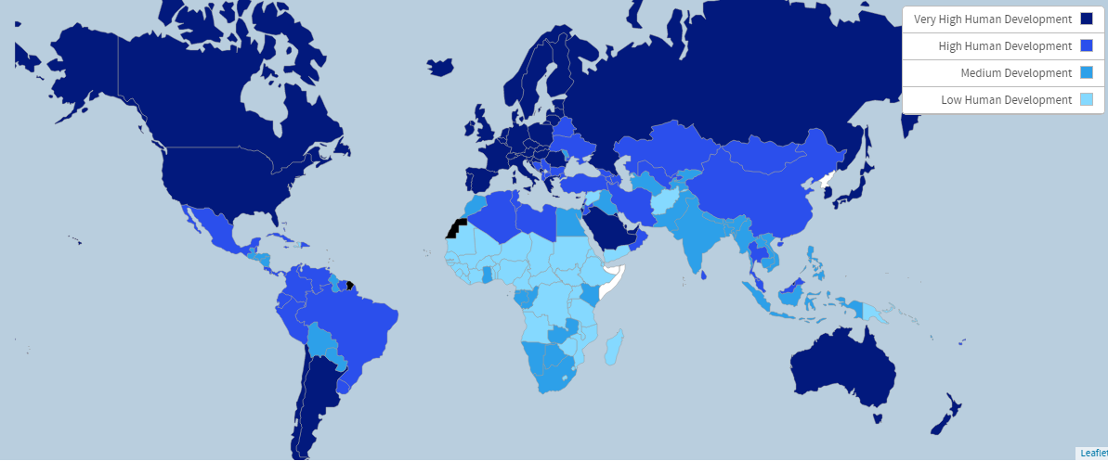
Figure 1 The list of countries shows only countries with the available HDI values.
Task 3 - Write a piece of commentary that describes the variation and spread of HDI today, including reference to the main IB focus countries

Country |  | HDI Index 2016 | Homicide Rate | Internet Users %

