|  |
| --- |
| **How is France Divided Up?** |

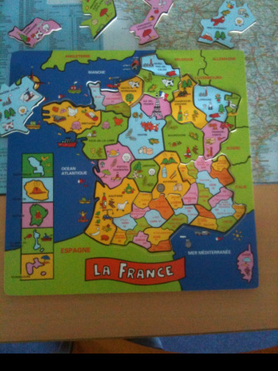

|  |
| --- |
| Use your jigsaw (like the one above) to answer the following questions:  How many regions are there in mainland France? |
|  |

|  |
| --- |
| How many Departéments are there in mainland France? |
|  |

|  |  |  |
| --- | --- | --- |
| Complete this table by using the following link. (<http://www.france-pub.com/list_france_departement.html>) | | |
| Departément number | Departément Name | Region Name |
|  | Aude |  |
| 30 |  |  |
|  | Somme |  |
| 31 |  |  |

|  |
| --- |
| In which Departément would you find Mont Blanc? |
|  |

|  |
| --- |
| In which Departément would you find the Eiffel Tower? |
|  |

|  |
| --- |
| In which Departément would you be able to go surfing in Biarritz? |
|  |

|  |
| --- |
| **DOM & TOM** |
| Using the maps of the French DOM & TOMS below and Google Maps, plot and label their location onto the world map below. |

