IB Geography – Hazards & Disasters
Case Study Summary Sheet for the Horn of Africa Drought 2011 (LEDCs)
Where did it happen?
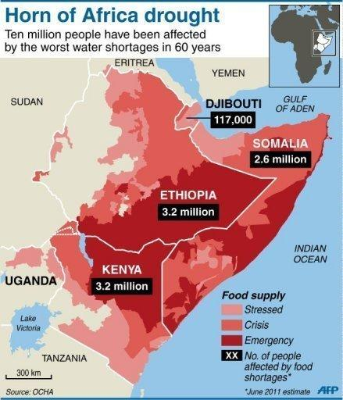
Between July 2011 and mid-2012, a severe drought affected the entire East Africa region. Said to be "the worst in 60 years", the drought caused a severe food crisis across Somalia, Djibouti, Ethiopia and Kenya that threatened the livelihood of 9.5 million people. Many refugees from southern Somalia fled to neighboring Kenya and Ethiopia, where crowded, unsanitary conditions together with severe malnutrition led to a large number of deaths. Other countries in East Africa, including Sudan, South Sudan and parts of Uganda, were also affected by a food crisis.
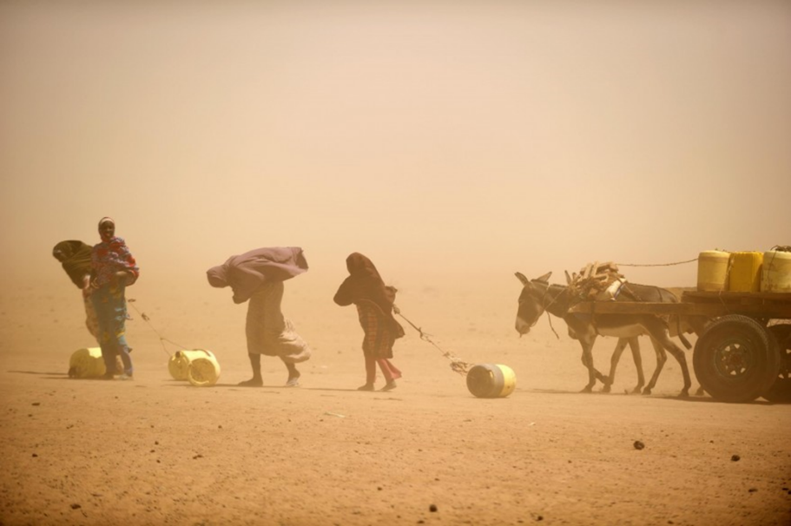

CIA Fact Box – Ethiopia (worst affected country) Need To Know
Indicator | Values (2014 estimated)
GDP per capita PPP | $1300
People Living in Poverty (less than $2 per day) | 39% of the population
Access to Clean Water | 52% of the population
Life Expectancy | 61 years
Literacy Rate | 39%
People Per Doctor | 0.03 doctors per 1000 people

When did it happen?
Date. This is a creeping phenomenon and dryer than average conditions have been prevalent in the area since the early 1980’s. Recent droughts in the area have been recorded in 1984-85, 1991-92 and 1998-99.
Duration. The drought hazard has been occurring in the Horn of Africa since late 2010 and lasted until 2012 in many areas. The area is still in 2015 under great water stress and the hazards is still a real and present threat.

Why did it happen?
Weather conditions over the Pacific, including an unusually strong La Niña, have interrupted seasonal rains for two consecutive seasons. The rains failed in 2011 in Kenya and Ethiopia, and for the previous two years in Somalia. In many areas, the precipitation rate during the main rainy season from April to June, the primary season, was less than 30% of the average of 1995–2010. The lack of rain led to crop failure and widespread loss of livestock, as high as 40%–60% in some areas, which decreased milk production as well as exacerbating a poor harvest. As a result, cereal prices rose to record levels while livestock prices and wages fell, reducing purchasing power across the region. The crisis is compounded by rebel activity around southern Somalia from the Al-Shabaab group.
The head of the United States Agency for International Development, Rajiv Shah, stated that climate change contributed to the severity of the crisis. "There's no question that hotter and drier growing conditions in sub-Saharan Africa have reduced the resiliency of these communities. «On the other hand, two experts with the International Livestock Research Institute suggested that it was premature to blame climate change for the drought. While there is consensus that a particularly strong La Niña contributed to the intensity of the drought, the relationship between La Niña and climate change is not well-established
Who was affected by it happening?
Social Impacts | Economic Impacts
Some reports of 260,000 deaths from the drought in Somalia alone between 2011–2012.  Within the camps, infant mortality had risen threefold in the few months leading up to July 2011. The overall mortality rate was 7.4 out of 10,000 per day, which was more than seven times as high as the "emergency" rate of 1 out of 10,000 per day  By 15 September 2011, more than 920,000 refugees from Somalia had reportedly fled to neighboring countries, particularly Kenya and Ethiopia.  At the height of the crisis in June 2011, the UNHCR base in Dadaab, Kenya hosted at least 440,000 people in three refugee camps, though the maximum capacity was 90,000  More than 30 percent of children were suffering from acute malnutrition; more than two adults or four children were dying of hunger each day for every group of 10,000 people; and the population had access to less than 2,100 kilocalories of food and four liters of water per day. | Staple food (vegetables, grains & seeds) prices were at 68% over the five-year average, including increases of up to 240% in southern Somalia, 117% in south-eastern Ethiopia, and 58% in northern Kenya  The World Food Programme said that it expected 12 million people across the Horn of Africa region to need food aid, with 2.8 million in southern Somalia alone, which was the most affected area  Humanitarian agencies requested US$2.48 billion to address the crisis.
Environmental Impacts | Political Impacts
Overgrazing and over cultivation of drought prone areas led to desertification and degradation of land.  Deforestation surrounding the large refugee camps set up to house the hundreds of thousands of refugees. Wood used for shelter and fuel. | Governments of countries affected by droughts asked for international and humanitarian assistance.  The Ethiopian government has called for humanitarian assistance every year since 1984 for drought and subsequent famine events.

What happened? *Leave this until we complete the next section on risk assessment and adjustments & responses to hazards
Management of the drought in the Horn of Africa
Before the event
The failure of the international community to heed the early warning system was criticized for leading to a worsening of the crisis. The Famine Early Warning Systems Network, financed by U.S.A.I.D., anticipated the crisis as early as August 2010, and by January 2011, the American ambassador to Kenya declared a disaster and called for urgent assistance. On 7 June 2011, FEWS NET declared that the crisis was "the most severe food security emergency in the world today, and the current humanitarian response is inadequate to prevent further deterioration". The UN later announced on 28 June that 12 million people in the East Africa region were affected by the drought and that some areas were on the brink of famine, with many displaced in search of water and food. Oxfam's humanitarian director Jane Cocking stated that “This is a preventable disaster and solutions are possible.”

During the event
Soon after a famine was declared in parts of southern Somalia. Oxfam also charged several European governments of "wilful neglect" over the crisis. It issued a statement saying that "The warning signs have been seen for months, and the world has been slow to act. Much greater long-term investment is needed in food production and basic development to help people cope with poor rains and ensure that this is the last famine in the region

After the event - The following initiatives have helped to prevent droughts and help the community to recover following a drought:
Pastoralist Livelihoods Initiative (PLI)
Enhanced Livelihoods in the Mandera Triangle/Southern
Ethiopia (ELMT/ELSE) programme,
Regional Resilience Enhancement Against Drought (RREAD) programme

Horn of Africa Drought needs sustainable solutions to prevent a reoccurrence of this situation in the medium and long-term
- Investing in the restoration and maintenance of the Earth's ecosystems can have a key role in countering climate change as well as climate-proofing vulnerable economies.
Adaptation Measures:
- supporting the restoration of Kenya's Mau forest
- to help introduce new policies in Ethiopia, that will assist pastoralists in managing climate change risks and shocks in six districts
- councils to help improved drought resilience and water security

Planning, preparation, prediction, hazard mapping, evacuation, warnings.
Learning from previous drought events
Occurs annually or bi-annually but the most severe cases were in;
1983-1985
1991-1992
1998-1999
2011 – the worst case of drought in the Horn of African for over 60 years.

Preparation – see this article from The Guardian

Prevention & Recovery

Help with recovery, aid - local, regional and international, role of NGOs.
Rescue (short) Rehabilitation (Medium) Reconstruction (Long)
Rescue

Rehabilitation

Reconstruction

