IGCSE Geog – The Gambia a High (Youthful) Dependent Population
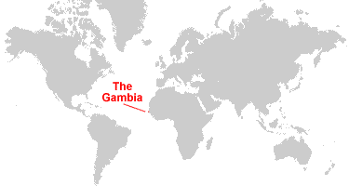
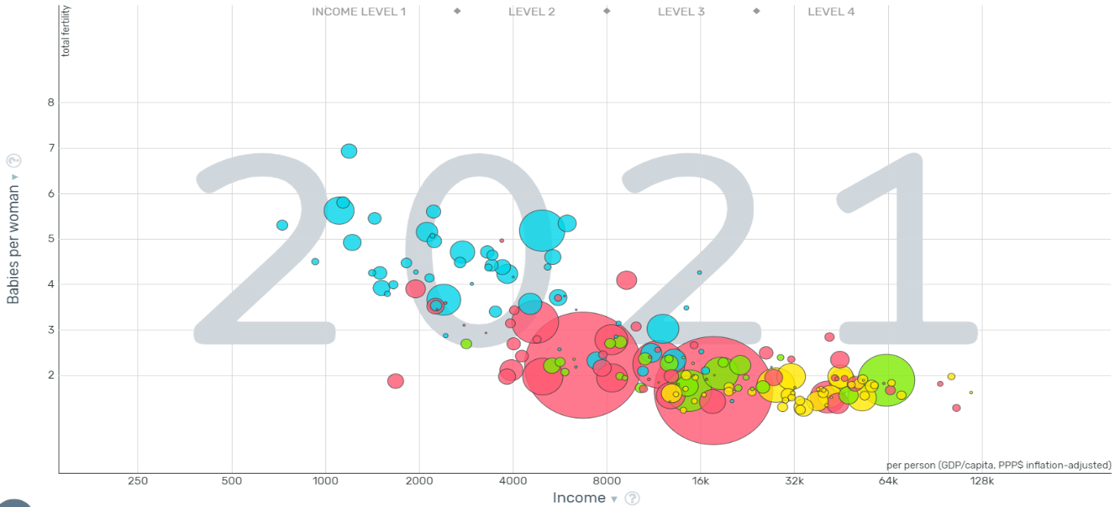
Write a description about where The Gambia is located. What is unusual about the shape of the country and border?

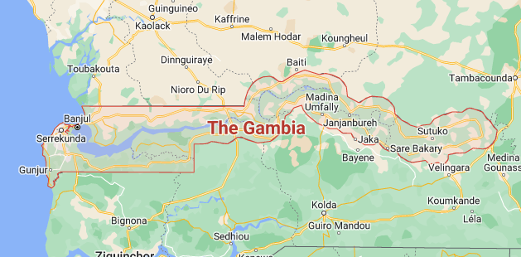
What was one of the unusual claims about the reason for the shape of The Gambia? (link)

Comment on the relationship between level of development and youthful populations. You can use this Gapminder bubble chart. Don't forget to name Gambia and interpret their data.

Use this weblink to make a list of the top 3 (according to you) positive and negative factors generally for a country.

What are the positives and negatives of a youthful population?
Positive | Negative
What are the solutions and how well do you think they would work? Who might be upset?

The situation in The Gambia
Problems
- High dependency ratio – this has resulted in widespread financial problems, with families not having enough money to feed and support their children. Infant malnutrition is common.

- Places of residence are often overcrowded – sanitation is very poor and homes often don’t have access to electricity

- Desertification – the carrying capacity of the land is quickly being exceeded, forests are being cut down for timber used in fires, house construction and selling.

- Lack of education – shortage of educational material, schools are forced to adopt a 2 shift system where some children are educated in the morning, and others later in the day. Furthermore, 1 in 3 14 year olds have to work in order to support their family.

The following information is not relevant to The Gambia, but should you be asked a specific question on the positive or negatives of an ageing population (which is also classed as high dependents – old dependents), you have some good content to write about.

Use this weblink to make a list of the top 3 (according to you) positive and negative factors.

What are the positives and negatives of an ageing population?
Positive | Negative
What are the solutions and how well do you think they would work? Who might be upset?

Exam corner:

For a named country you have studied, describe the problems caused by a high dependent population. (7)

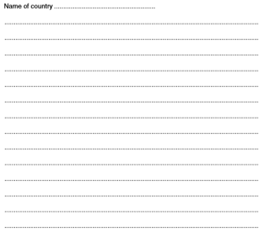
Remember:
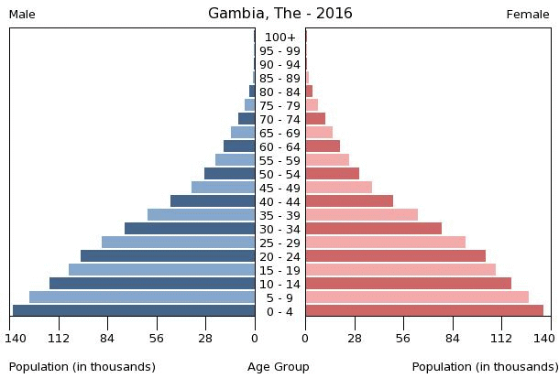
Dependent people can be classed as those on a population pyramid who are either under the age of 15 (young dependents) or over the age of 65 (old dependents). This is because people in these age categories generally don't work and are supported by people in the economically active sector aged 16-64.
​This is quite a general assumption and there are many factors that might mean that children may actually work before 16 or that elderly people still work into their 70's. Study the population pyramid for The Gambia. The wide base shows a high fertility rate and a high youthful population (young dependents). There are also a considerable number of people surviving to over 60 years old (old dependents).

