IGCSE Geography – The Gambia a High Dependent Population
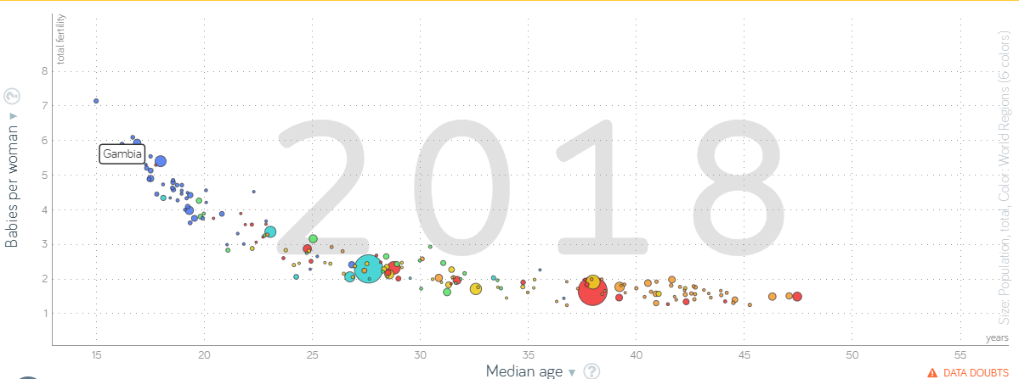

Comment on the relationship between level of development and youthful populations. You can use this Gapminder bubble chart. Don't forget to name at least five countries and what their data tells you.

Use this weblink to make a list of the top 3 (according to you) positive and negative factors.

What are the positives and negatives of a youthful population?
Positive | Negative
What are the solutions and how well do you think they would work? Who might be upset?

Use this weblink to make a list of the top 3 (according to you) positive and negative factors.

What are the positives and negatives of an ageing population?
Positive | Negative
What are the solutions and how well do you think they would work? Who might be upset?

Exam corner:

For a named country you have studied, describe the problems caused by a high dependent population. (7)

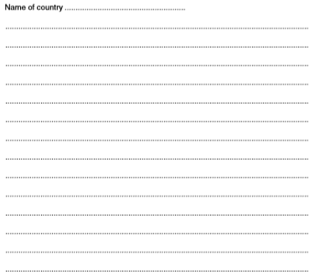
Remember:
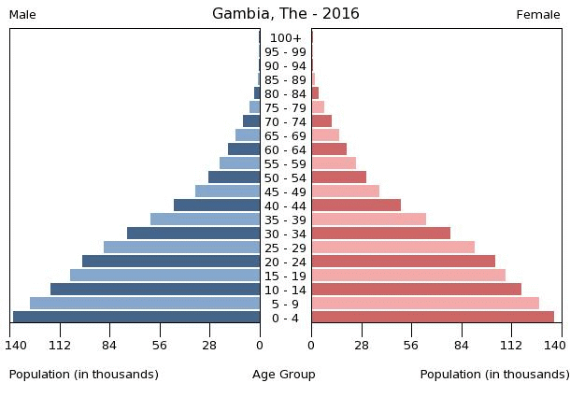
Dependent people can be classed as those on a population pyramid who are either under the age of 15 (young dependents) or over the age of 65 (old dependents). This is because people in these age categories generally don't work and are supported by people in the economically active sector aged 16-64.
​This is quite a general assumption and there are many factors that might mean that children may actually work before 16 or that elderly people still work into their 70's. Study the population pyramid for The Gambia. The wide base shows a high fertility rate and a high youthful population (young dependents). There are also a considerable number of people surviving to over 60 years old (old dependents).

