**What are the most frequent causes for the rise of dictators?**

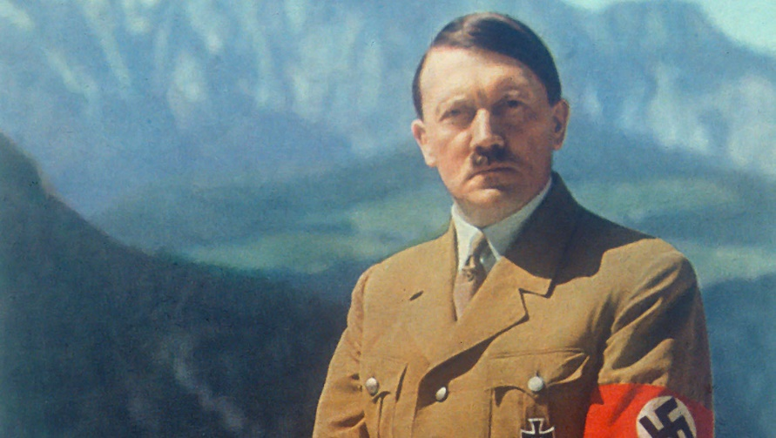**Comparisons and Contrasts: Venn Diagram**

[Overall conclusion goes here]

