IGCSE Geography – Hydro Electric Case Study
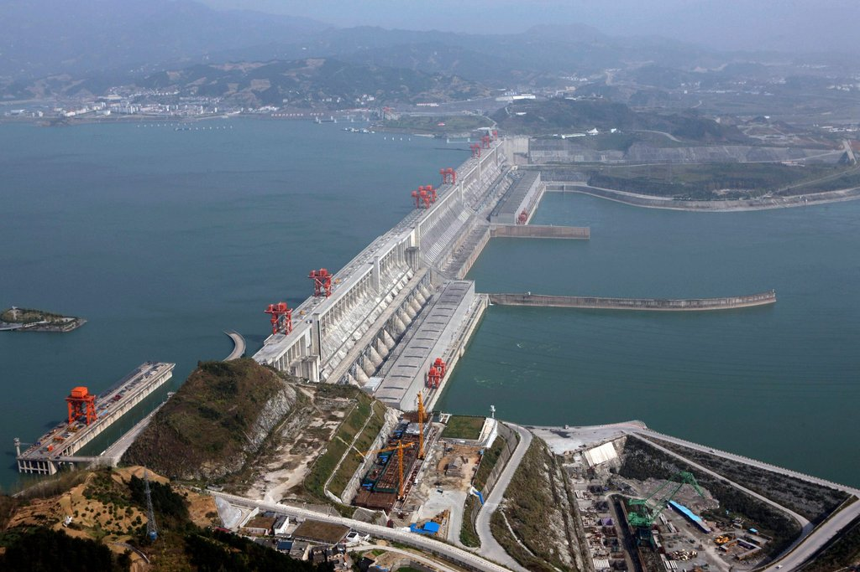
The Three Gorges Dam is a hydroelectric gravity dam that spans the Yangtze River by the town of Sandouping, in Yiling District, Yichang, Hubei province, China. The Three Gorges Dam has been the world's largest power station in terms of installed capacity (22,500 MW) since 2012 (Wikipedia). The map below shows you the location of the dam within China.
China is one of the biggest investors in the world in renewable energy with vast amount of money being spent on solar, wind and HEP.

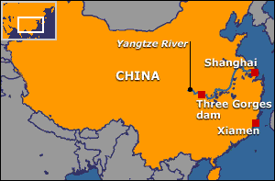
Advantages of The Three Gorges Dam Project

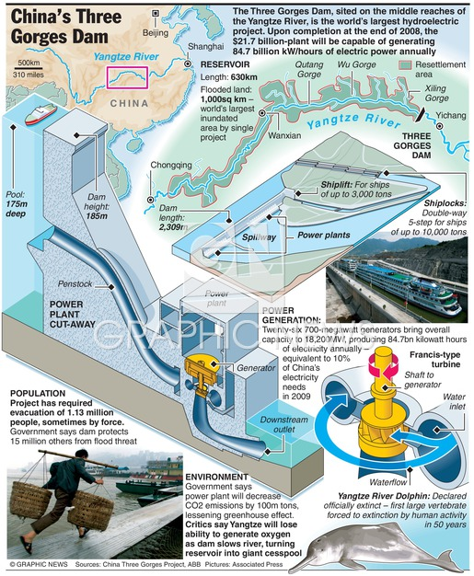
Using the infographic above, find three advantages of the scheme.
Advantage 1 | Advantage 2 | Advantage 3

Disadvantages of the Three Gorges Dam
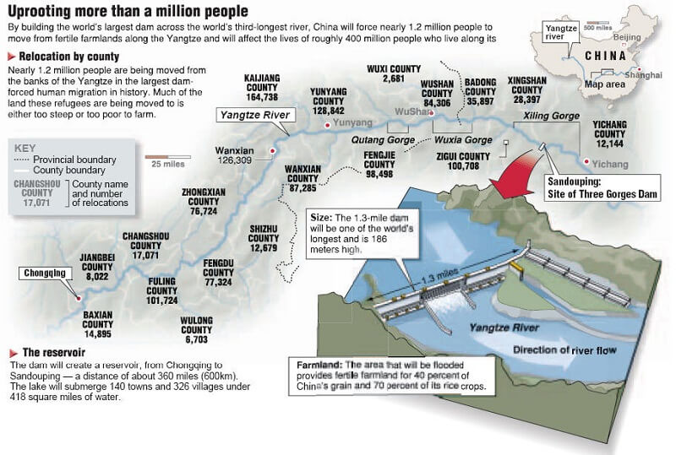
Using both of the infographics above, find three disadvantages of the scheme.
Disadvantage 1 | Disadvantage 2 | Disadvantage 3

Video Notes Sheet

0 - 4 Minutes
What is the claim to fame of this Dam?

How long and tall is the dam?

How many workers did it take to construct?

How many years to build?

How much power will it produce?

Why was the dam built?

Which river does it span?

What did the authorities have to do before they created the dam?

What are the benefits of the dam to the Chinese authorities?

Fast Forward to 8:48

How much does each generator cost inside the dam and how many are there in total in the Three Gorges Dam?

Fast forward to 15:35

How long is the Yangtze river?

How many acres of land will be flooded by the reservoir?

How many Chinese people will have to be relocated?

What do they do with these people?

Fast forward to 36:22

Explain the effects of the dam on shipping and transportation.

How was the problem overcome?

Fast Forward to 40:00

Explain how the authorities hope to control flooding with the dam.

What are the side effects of creating a dam?
Excuse the dead snails being blended!!

Which groups of people would be most affected by this dam?

How do the Chinese authorities solve this problem?

