IB Geography – Hazards & Disasters
Case Study Summary Sheet for Haiyan Typhoon 2013 (LEDC)
Where did it happen?
The Philippines area series of islands located in the South China Sea, east of Vietnam and north of Indonesia. The capital of the Philippines is Manila. This islands regularly suffer from considerable typhoons that sweep in from the south west every year during the tropical storm season. Typhoon Haiyan originated from an area of low pressure several hundred kilometers east-southeast of Pohnpei in the Federated States of Micronesia on November 2, 2013. Moving generally westward, the system developed into a tropical depression the following day. After becoming a tropical storm and attaining the name Haiyan on November 4, the system began a period of rapid intensification that brought it to typhoon intensity on November 5. Haiyan is unofficially the fourth most intense tropical cyclone ever observed.
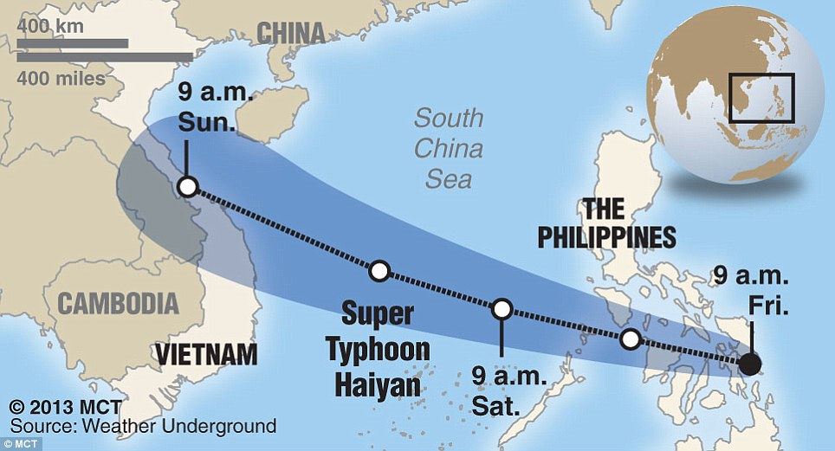

CIA Fact Box – Philippines Need To Know
Indicator | Values (2014 estimated)
GDP per capita PPP | $4700
People Living in Poverty (less than $2 per day) | 27% of the population
Access to Clean Water | 95.4% of the population
Life Expectancy | 72 years
Literacy Rate | 48.7%
People Per Doctor | 1.15 doctors per 1000 people

When did it happen?
Date. Struck the Philippines on November 7th & 8th 2013
Time (local). Late afternoon and night time – high winds and devastating storm surge.
Duration. The tropical depression was first tracked on 2nd November and continued to grow and feed off the tropical ocean temperatures developing into a fully-fledged tropical storm on 4th November and then rapidly intensified into the most powerful tropical storm every recorded making landfall on 7th November then making a further 5 landfalls (other Filipino islands) as is crossed the country, before heading north westwards over the South China Sea and eventually to Vietnam as a severe tropical storm.

Why did it happen?
Other than the traditional recipe for typhoon formation (sea temperatures over 27°c and rotating winds over the ocean's surface) is sea-level rise, caused by global warming that many say should be considered. Since 1900, the waters have crept up by about 20cm, on average, around the world, and the rate of increase has almost doubled over the past two decades. Higher seas have long been known disproportionately to contribute to greater storm surges.
The recent rise near the Philippines has been the highest anywhere in the world, at three times larger than the global average, as natural changes in the winds have piled up the water. At the same time, abstracting too much groundwater has caused parts of the country to sink. And to make things even worse, Tacloban stands at the end of a bay that might have been designed to funnel water into destructive storm surges.
Because of all this, a surge some 4 metres high swept through the city, causing far more destruction, and killing far more people, than the winds themselves. Both natural and man-made factors were to blame, but climate change played an important part. “The impact of this cyclone,” says Michel Jarraud, secretary-general of the World Metereological Organisation, “was definitely significantly more than what it would have been 100 years ago because of the simple mechanical fact that the sea level is higher.”
Who was affected by it happening?
Social Impacts | Economic Impacts
Killed 7500 people and affected 9 million people.  The Philippines faces a humanitarian crisis days after the typhoon hit much of the Visayas with 1.9 million homeless and more than 6,000,000 displaced.  The United Nations fear that the possibility of the spread of disease is high due to the lack of food, water, shelter, and medication.  Casualties were reported as a result of the lack of aid in affected areas  Areas less affected areas reported that their populations more than doubled after the typhoon with the influx of refugees into the city. | The economic impact is estimated at $2.9 billion?  The major rice and sugar producing areas for the Philippines were destroyed.  Coconuts account for nearly half the Philippines agricultural exports and the country is the world’s biggest producer of coconut oil.  Between 50,000 tons and 120,000 tons of sugar may have been lost, the Sugar Regulatory Administration estimated.  The Philippine government estimated that about 71,000 hectares (175,000 acres) of farmland were affected; 3.7 billion pesos ($85 million) was lost from farm damage.  A total of 131,611 tons of rice was lost, equivalent to a 1.8 per cent reduction in fourth quarter output, and about 4,000 tons of corn were destroyed.
Environmental Impacts | Political Impacts
Environmental devastation and loss of forests, trees and widespread flooding.  Oil and sewerage leaks into the local ecosystems.  Lack of sanitation in days following the event also leads to a higher level of pollution.  The Food and Agriculture Organisation (FAO) reports that hundreds of thousands of hectares of rice have been destroyed.  Coconut plantations which are a big source of foreign currency were said to be “completely flattened”  Fishing communities have also be severely affected with the storm destroying boats and associated equipment. | The Philippines formally declared "A State of National Calamity" and asked for international help, one day after the Haiyan hit the country.  A week after the typhoon had struck, President Benigno Aquino was under growing pressure to speed up the distribution of networks or food, water and medicine to desperate survivors and to get paralysed local governments functioning.  The Tacloban city government was decimated, with just 70 workers in the immediate days after the disaster compared to 2,500 normally. Many were killed, injured, lost family or were simply too traumatised to work.  The United Nations has admitted its response to the typhoon disaster in the Philippines had been too slow, amid reports of hunger and thirst among desperate survivors.

What happened? *Leave this until we complete the next section on risk assessment and adjustments & responses to hazards
Management of the typhoon hazard in the Philippines.
Before the event

During the event

After the event -

Planning, preparation, prediction, hazard mapping, evacuation, warnings.

Help with recovery, aid - local, regional and international, role of NGOs.
Rescue (short) Rehabilitation (Medium) Reconstruction (Long)

