G8 Geography - The Human Development Index (HDI)
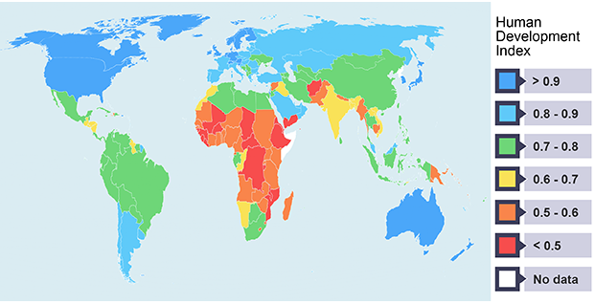
What does HDI stand for?

Name the four composite indicators that are included in HDI. Which are social and which is economic?

On what scale is HDI measured?

Which country has the highest HDI score in the world and what is their score? Which country is the lowest in the world and what is their score?

Using the BBC site hyperlinked on geographypods, note down some of the advantages and disadvantages of the HDI below.
Advantages | Disadvantages

Fill in the data using the website linked on geographypods.com

Country | HDI value | Life Expectancy | Mean Years of Schooling | Expected Years of Schooling | GNI per capita $
France | 0.891 | 82.5 | 11.4 | 15.5 | 40,511
Niger
Norway
*home country*

In the space underneath, comment on the each of the HDI graphs as set out in the instructions on geographypods.com. The first one has been done for you.
France (paste graph and comment on trend)
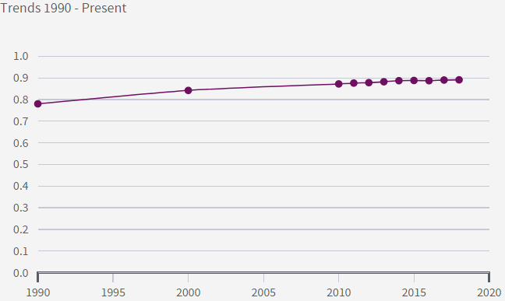

The graph above shows that France already had a high ranking on the HDI back when the HDI league was invented in 1990. The value rose from 0.79 to 0.85 in the decade from 1990 to 2000 and the following 18 years have seen a further rise to 0.89. Since 2000, the rate of progress has slowed perhaps due to the economic recession, migration and terrorism within the country.

Niger (paste graph and comment on trend)

Norway (paste graph and comment on trend)

Your home country (paste graph and comment on trend)

Look back at the map on the first page. Describe the distribution (where they are) of high and low ranking countries. Does this still follow the Brandt Line pattern?

