G6 Factfulness – An Introduction
Have you ever had a really scary moment in your life? Write a few words about what happened in the space below.

Now, tell me about the best thing that happened to you when you were 10 years old.

Which of the above two tasks was the easiest to complete? Why do you think this was?

So, it’s the end of August 2019 and I decided to have a look around at what was trending on various popular news sites around the world. Here are a selection of headlines from today (26th August).
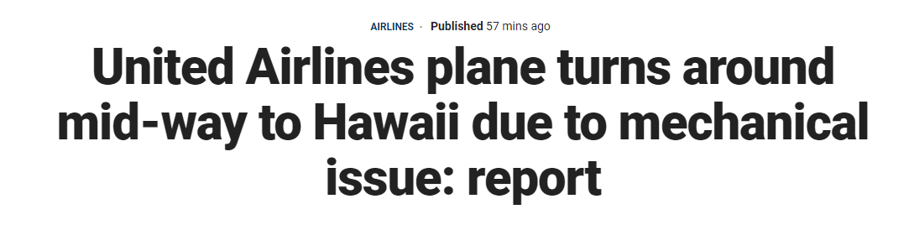
The headline above was from FOX News in the USA. Is this good or bad news and why?
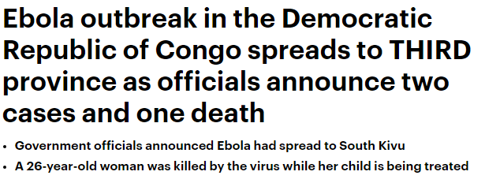
This headline is from the Daily Mail in the UK. Is this good or bad news and why?

Now go to the site where you get your news. Do a quick count of the headlines and tally up the number of stories into the categories below.
Good News | Bad News | A bit of both
Did you get more good news or bad? Why could this be?

Factfulness & Air Travel
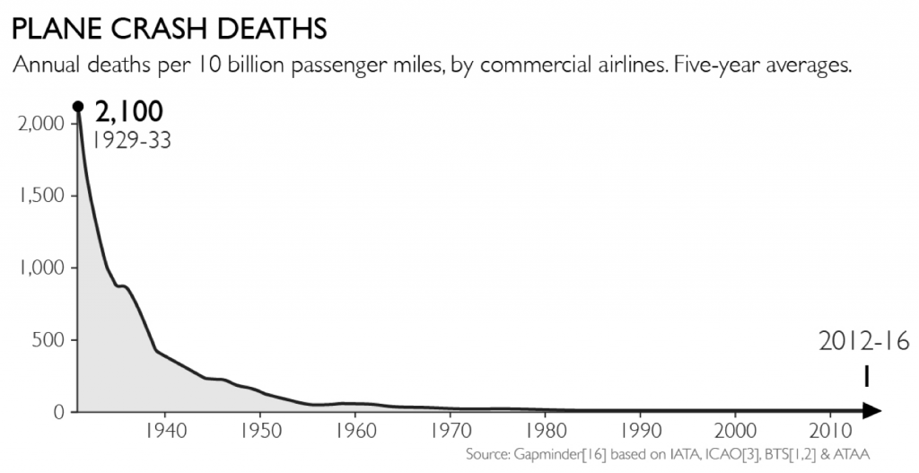

Study the graph above carefully. How much safer has flying got between 1929-1933 and 2012-2016?

Did you know? In 2016, a total of 40 million commercial passenger jets landed safely at their destinations. Only 10 ended in fatal accidents. Those were the ones that journalists wrote about. A quick mathematical calculation will show that that is 0.000025% of the total flights. (Source: Factfulness)

Just imagine therefore that the headline on the previous page from Fox News wasn’t about a plane crash, but instead about a plane that had a technical problem (and that returned to the airport safely). Is this even news?

Using the information above, write an alternative positive headline about the Air France flight that landed this morning at our local airport from Berlin.

Factfulness & Infectious Diseases

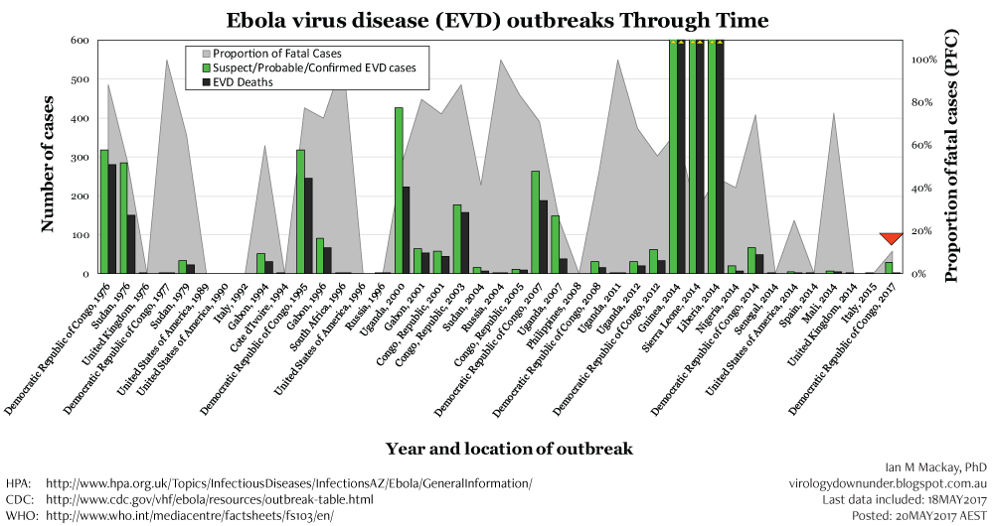

The graph above shows the cases of Ebola virus disease (EVD) over time.

It shows you where the outbreaks happened in the world, how many cases there were and how many people died. The grey part of the graph also shows you the proportion of fatal cases.

Is Ebola a constant problem? Write down you thoughts on the graph below.

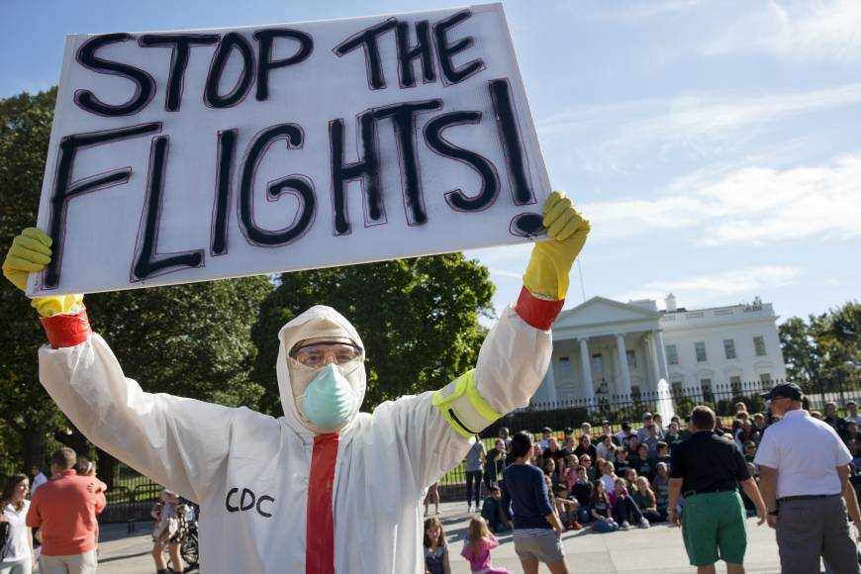

Mountains Out of Molehills
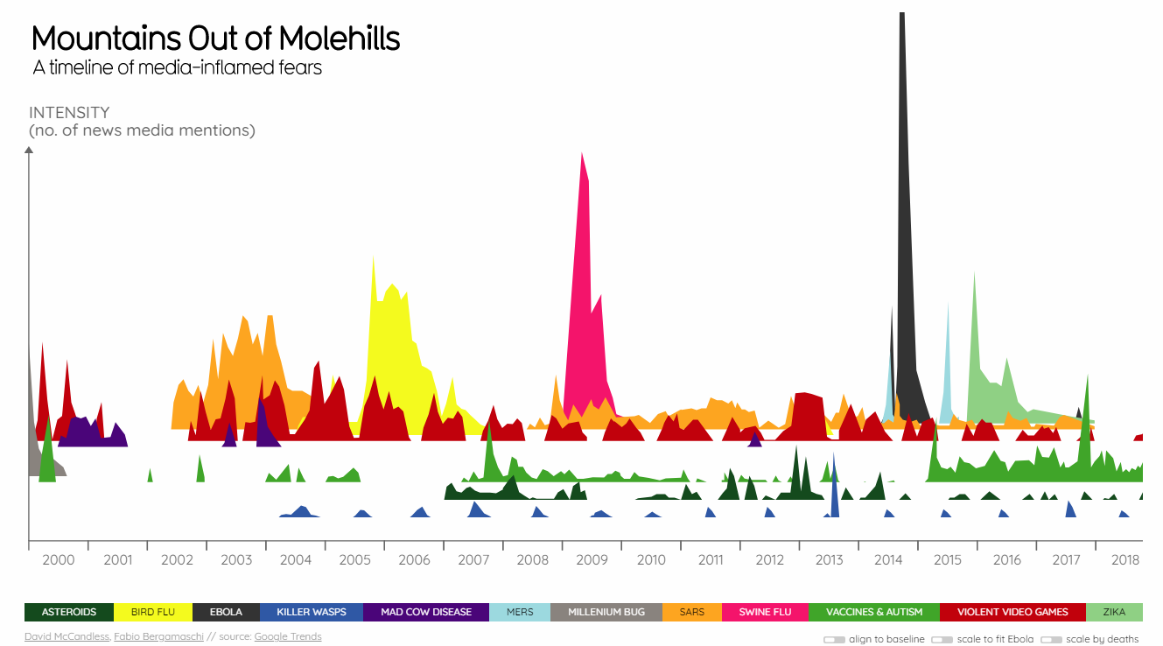
Using geographypods, click on the link to take you to this excellent site from ‘Information is Beautiful’. Alternatively, click on the image above.

It shows you key events (check out the colour categories along the bottom) and how much media attention was given to them. If you click on the categories and the spikes, it gives you some further information.

- Choose any one of the factors and do a search on your favourite news site.
- Then explain why it gets media coverage.

Category:

Most recent news story & news site:

Why so much media coverage:

Factfulness & The Negativity Instinct

Factfulness is . . . recognizing when we get negative news and remembering that information about bad events is much more likely to reach us. When things are getting better we often don’t hear about them. This gives us a systematically too-negative impression of the world around us, which is very stressful.
To control the negativity instinct, expect bad news.

• Good news is not news. Good news is almost never reported. So news is almost always bad. When you see bad news, ask whether equally positive news would have reached you – Think about the plane scenario.

• Gradual improvement is not news. When a trend is gradually improving, with periodic dips, you are more likely to notice the dips than the overall improvement. Think about the Ebola scenario.

• More news does not equal more suffering. More bad news is sometimes due to better surveillance of suffering, not a worsening world. Think about how many news sites there are nowadays, YouTube, Instagram, Twitter etc.
Source: https://www.gapminder.org/factfulness/negativity/

