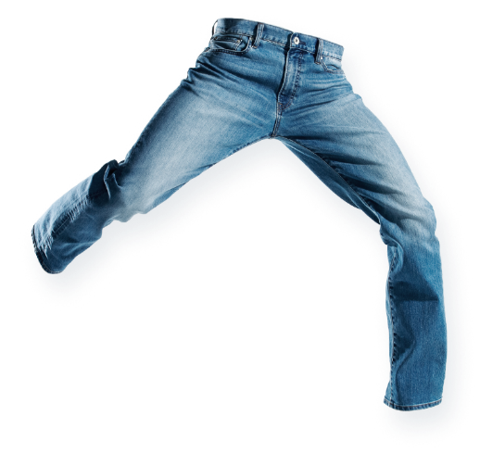
GLOBAL JEANS – G7 GEOGRAPHY
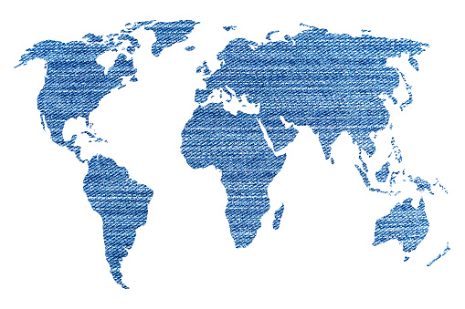
Task - Cut out the labels from the worksheet and place around the map with arrows pointing to countries involved. Make sure that no arrows overlap.

