GLOBAL JEANS – YEAR 8 GEOGRAPHY
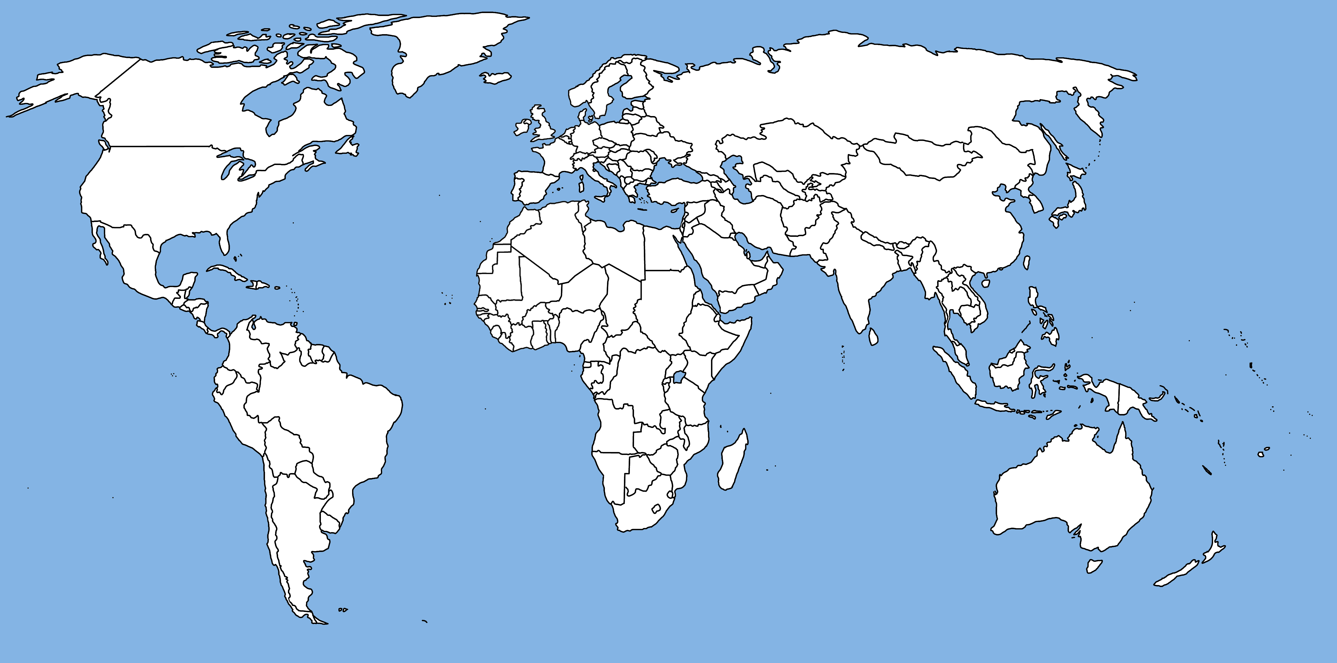
Task - Cut out the labels from the worksheet and place around the map with arrows pointing to countries involved. Shade in those countries too.

