The 2015 Nepal Earthquake
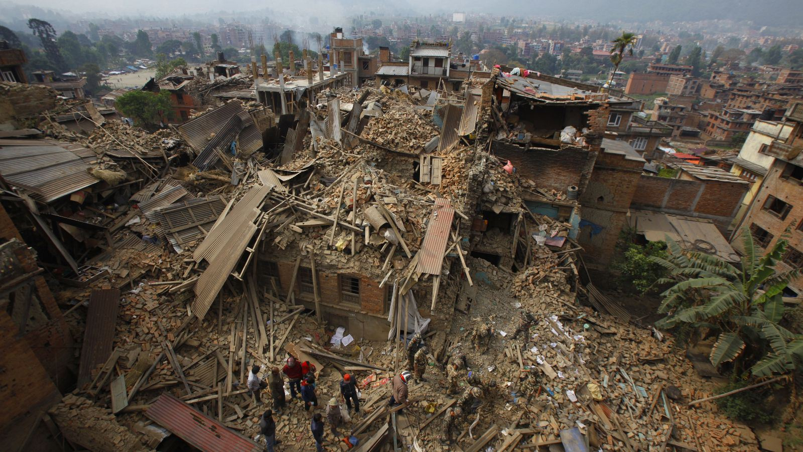
Figure 1 - Source Qz.com
You will be carrying out an independent investigation into the recent devastating earthquake in Nepal. All tasks are listed on geographypods.com but can be completed on this worksheet. Remember, the full extent of this disaster is not yet known. The information you find out today will likely change considerably over the next few days and weeks. You should keep updating this document by watching the news and reading good quality media sites.

Starter Task – After watching the tourist video in Kathmandu, write down seven adjectives that describe the images and sounds in the film.
1
2
3
4
5
6
7

Task 1 – You have survived the earthquake, using the instructions on geographypods, write your Tweet here. 140 characters only. Check by highlighting the tweet text and click on Review – Word Count – Characters (with spaces).

Task 2 – Where is Nepal? In the space below find a suitable map that shows where Nepal is in the world. Copy and paste it in and add the source of the information.

Task 3 – More about Nepal. Complete the sentences underneath by choosing the correct words from the box beneath.
Nepal is located between the countries of _____________ and _______________. The capital city is called __________________ and has ___________ inhabitants. Nepal is home the highest mountain in the world called _____________________. It is __________ metres high and is part of the __________________ mountain range. These mountains are actually _____________ every year as the _________ plate and the __________ plate push together. Nepal is home to 28 ____________ people. Many hundreds of _______________ and adventurers flock to Nepal every April and May to climb the most famous mountain in the world.

Million India Kathmandu Himalayan Eurasian Mount Everest

8850 growing Indian 700,000 mountaineers China

Task 4 – Find out what time the earthquake happened (local time) and on what date.

Task 5 - Do you think it would have been worse if it had happed and night and if so, why?

Task 6 - What did the earthquake cause to happen on the slopes of Mount Everest?

Task 7 - Watch this video on YouTube. Describe how the climbers at the base camp of Mount Everest must have felt as they heard the wall of snow and ice moving towards them at an incredible speed.

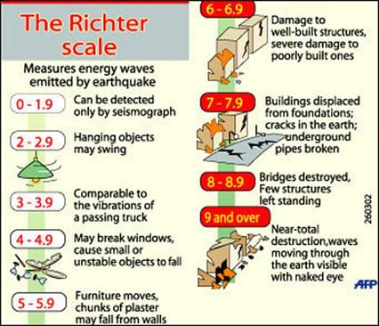
Task 8 - How powerful was the earthquake on Mount Everest? It is measured on the Richter Scale. You can see the impacts that quakes at different levels have from the diagram above.

Task 9 - Below is a series of images taken from the BBC News website. Please annotate each photo by answering the question above it.

Explain what has happened here in the last 72 hours
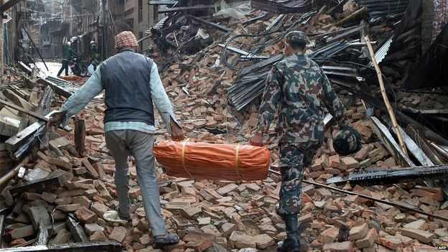

Where would you go to?
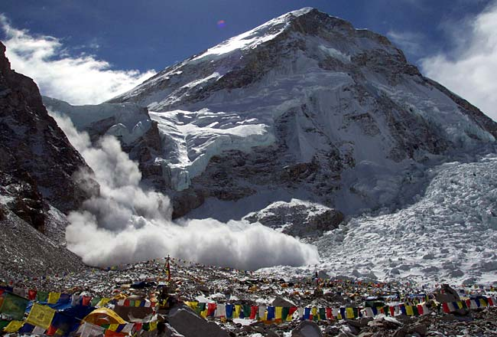

What eight things would you rescue if this was your house?
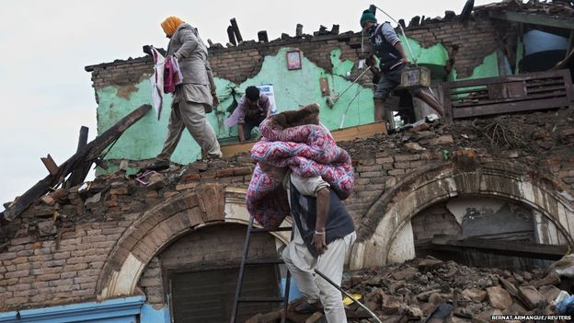

What are they going to need in the next three days?
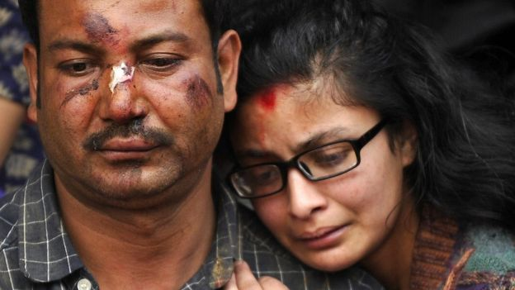

Are these people lucky or just unlucky?
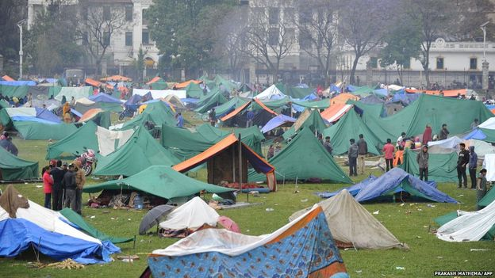

Effects of the Earthquake on Nepal
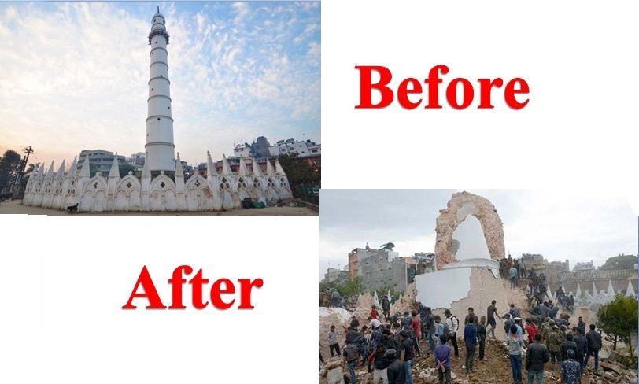
A quick search of ‘Nepal Earthquake 2015’ on Google images will show great destruction in the urban areas of Kathmandu and Pokhara. However, the damage in rural (countryside) areas has yet to be established.
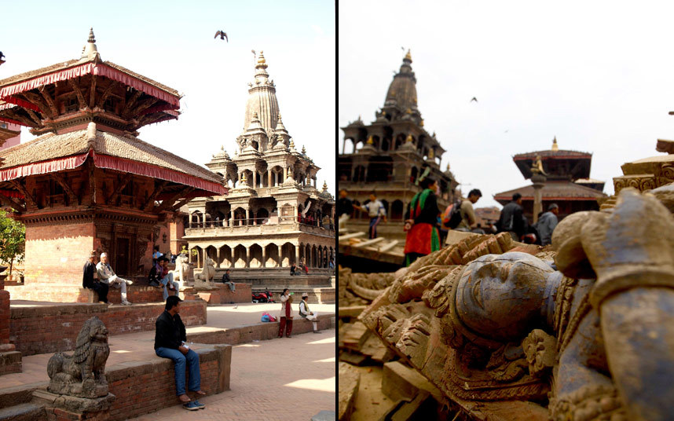
Task 10 - Why do you think that buildings such as those show above collapsed ? Is there anything that could have been done to make them withstand an earthquake? Make sure you watch the Google Earth video on geographpods.

Task 11 – Watch the embedded YouTube video on geographypods – Aerial Footage, Helicopters buzz Nepal epicentre destruction. Why is it so difficult to determine the impact of the earthquake on these remote areas where up to 70% of Nepal’s population live?
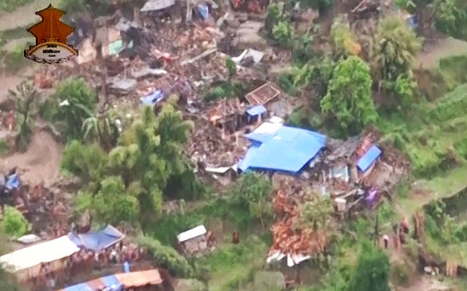

The Impact on Everest & the climbers
Task 12 – Using the Gigapixel interactive image and the YouTube video on geographypods, explain why the climbers at base camp had so little time to escape the avalanche that killed 17 others?

