**Geography**

**Grade 7 Renaissance Day**

Discovering the ‘lost world’

**Christopher Columbus**

**Good Guy/Bad Guy**

Aim: To raise our awareness of the Geography of the Renaissance and how exploration and mapping shaped understanding of the modern world.

[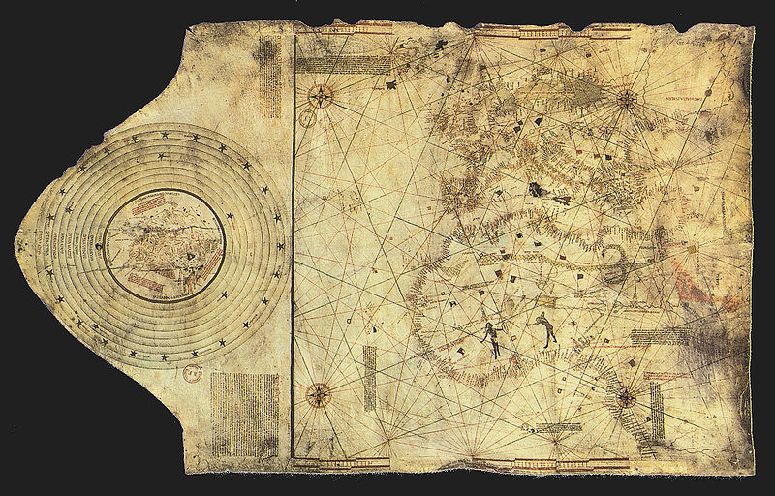](http://upload.wikimedia.org/wikipedia/commons/3/38/ColombusMap.jpg)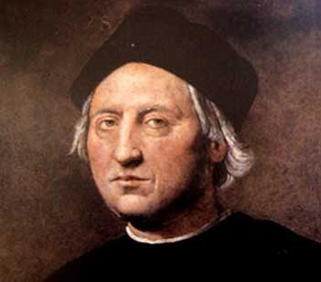

Name _________ Form ____

**Factfile**

Born:

Birthplace: , Italy

Died:

Best Known As: Discoverer of the New World

Also Known As: (Spanish) and (Italian)



Mission Objective: ………………………………………………………

………………………………………………………………………………………………………………………………………………………………………………………………………………………………………………………………..

**Historical mistake?**

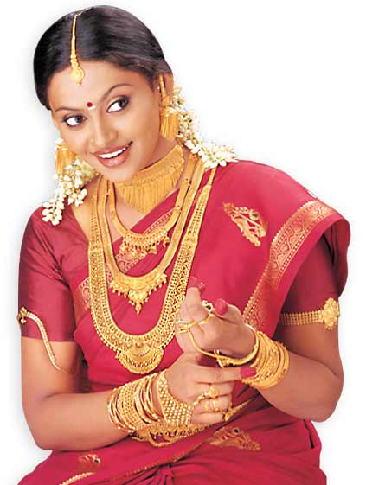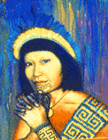

Explain inside the arrow above, how native Americans were given the name ‘Indians’.

Annotate onto the Juan Vespucci map below the names of countries and continents with which you are now familiar. Look at the maps on the wall in EC730 to help you.

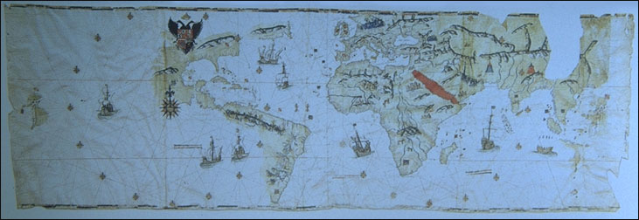

* In what way was Columbus responsible for the destruction of the Arawak civilization?

**Read ‘The Big Trade’**

* In your opinion, what were the three most important things that Europe got from America?
* In your opinion, what were the three most important things that America got from Europe?



**Mapping the fourth Mission**

Use the data on the following page and the longitude and latitude figures to plot the fourth voyage taken by Christopher Columbus.







**In Conclusion**

How successful were the Christopher Columbus Voyages of discovery? Did they set out to meet their aims? Did they cause more trouble than good? Did he help the likes of Magellan in his travels in 1517?

………………………………………………………………………………….....

………………………………………………………………………………….....

………………………………………………………………………………….....

………………………………………………………………………………….....

………………………………………………………………………………….....

………………………………………………………………………………….....

………………………………………………………………………………….....

………………………………………………………………………………….....

………………………………………………………………………………….....

………………………………………………………………………………….....

………………………………………………………………………………….....

………………………………………………………………………………….....

………………………………………………………………………………….....

………………………………………………………………………………….....

………………………………………………………………………………….....