GCSE Geography Hazards @ IST
Tropical Storms: Where and how?
Task 1 - List down five effects of hurricane force storms on people and the environment:
1.
2.
3.
4.
5.
Task 2 - Complete these Key terms:
Cyclone –
Hurricane –
Typhoon –

Task 3 - Annotate the information from p.134 onto the diagram below
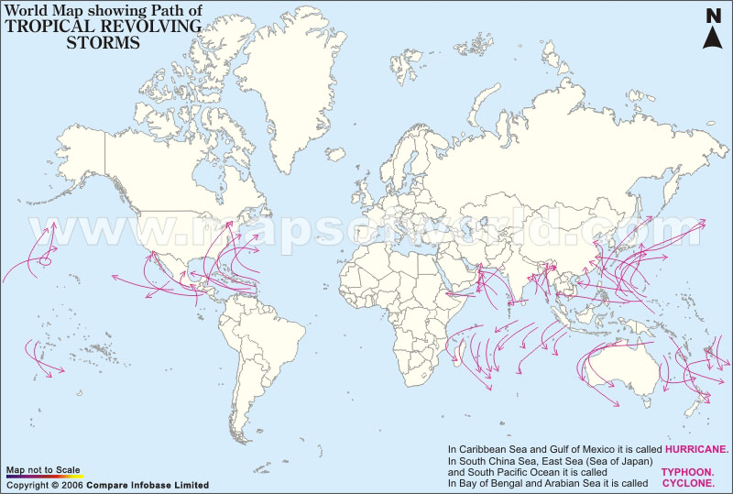

Task 4 - Key Ingredients for the formation of a tropical storm
Key Ingredient 1 –
Key Ingredient 2 –

Task 5 – Key features of a storm
Key Feature 1 –
Key Feature 2 -
Exam Studio
Explain how tropical storms form and describe their effects (8)
________________________________________________________________________________________________________________________________________________________________________________________________________________________________________________________________________________________________________________________________________________________________________________________________________________________________________________________________________________________________________________________________________________________________________________________________________________________________________________________________________________________________________
** Tips – Look at how many marks are available and try to use as many key terms as possible to impress the examiner**
Further research
Using the information on page 135, what is happening to the frequency of tropical storms? Use dates and locations in your response.
________________________________________________________________________________________________________________________________________________________________________________________________________________________________________________________________________________________________________________________________________________________________________________________________________________________________________________________________________________________________________________________________________________________________________________________________________________________________________________________________________________________________________

