Task 4 – A Rich Man’s Game – Gapminder Mapping Previous World Cup Winners
Country | Number of times won. | Income per person | Life Expectancy
Brazil
Italy
Germany
Argentina
Uruguay
France
England
Spain
Copy of 2012 Gapminder graph here for all previous winners.

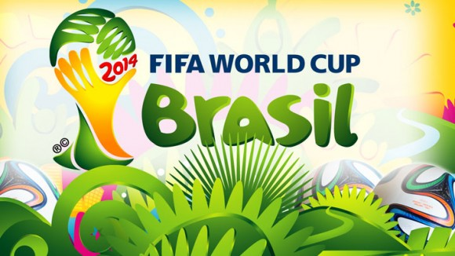

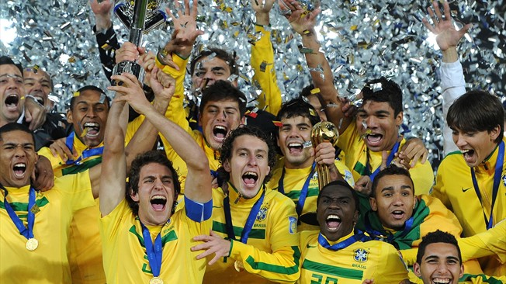
Commentary on GapMinder graph
1 Name the regions of the world that have not had a World Cup winner so far.

2 Which region seems to dominate the World Cup winners (orange)?

3 How many times have countries from this region won the World Cup?

4 What has happened to income per person and life expectancy in these countries over the last 200 years?

5 How many times have countries from the other world region won the World Cup?

6. Which country is the most successful?

7 What has happened to income per person and life expectancy in these three countries over the last 200 years?

8. What is the income per person and life expectancy gap between the most successful country from each of the two regions?

So, is there a relationship between the health and wealth of a country and their ability to win the World Cup? Write your answer below. Target 150 words.

