G8 Factfulness – The World Is Getting Worse

Write down five things that are getting worse in our world.

1
2
3
4
5

Put a tick in the box below that best fits your thoughts.

Statement |  | Tick
1 | The world is getting better
2 | The world is getting worse
3 | The world is staying about the same
Now collect the results from the class and enter them into a simple bar chart to the right. Complete both axes too.

Summarise the results below as a %.

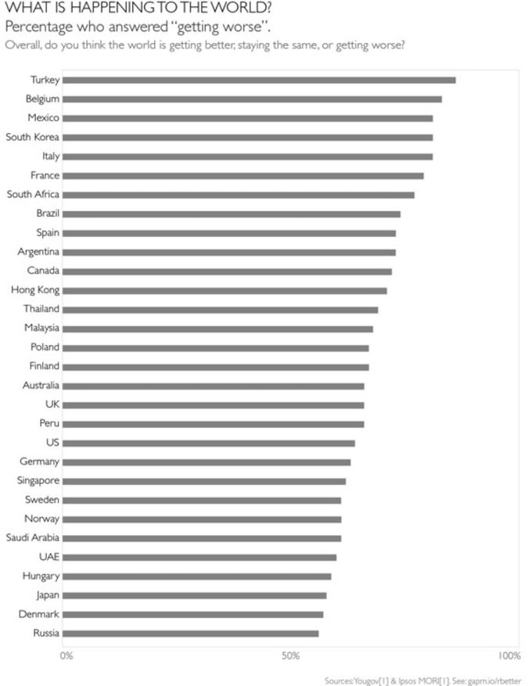
Above is a graph taken from the Factfulness book that shows the percentage of people from survey countries who replied ‘getting worse’.

Level 1 and 2 countries have much more to worry about than Level 2 & 3 countries.

How much to you agree with the statement above. Explain why in the space below.

In What Ways is The World Getting Better?

Two of the best ways of measuring basic human needs and survival are in poverty and life expectancy. As you will remember, both go hand in hand. More wealthy people live, on average, for longer.
Let’s have a look at two charts below.
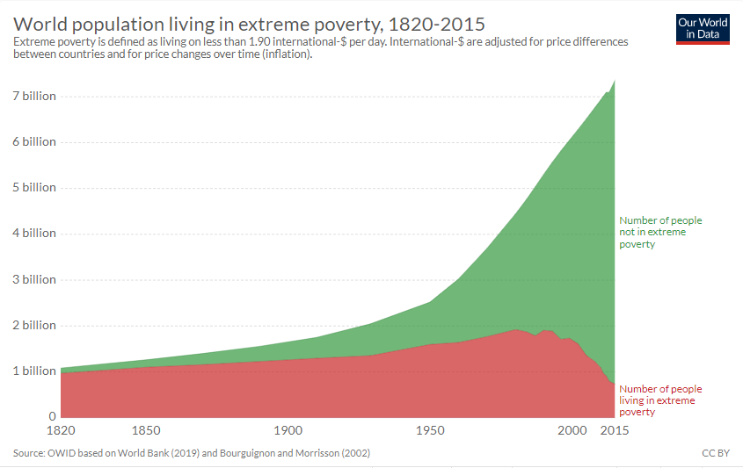
The graph above shows the number of people living in extreme poverty (red) and those who don’t (green). Using the interactive graph on geographypods, complete the tasks below:
Year and highest number population living in extreme poverty

Year and lowest number of population living in extreme poverty

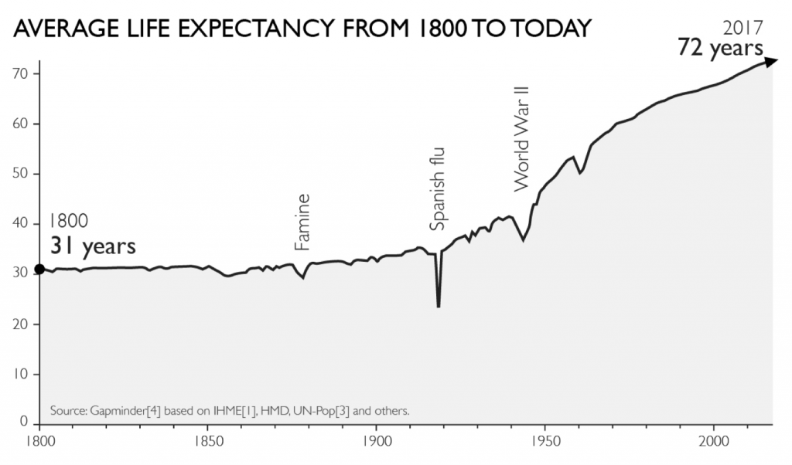

The graph above is from the Factfulness book and shows life expectancy increase over time. Describe the trend from 1800 to 2017 and state the total increase in life expectancy during this 217-year period.

