IGCSE Geography - The four processes of erosion
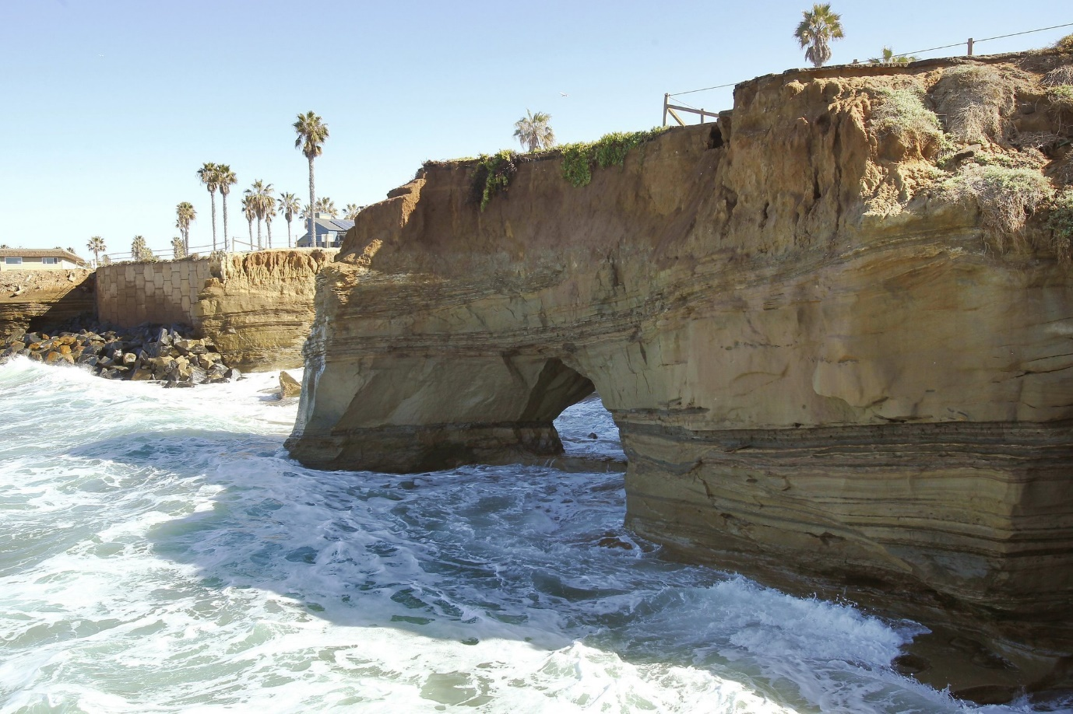
1 - Source - Dan Diego Tribune
Coastal Erosion (types of erosion)
Coasts being at the boundary of the land and the sea are extremely vulnerable to erosion. They are attacked by the immense power of the sea and the weather. The main ways that the sea erodes the coast are:
Process of erosion | Description | Diagram / Cartoon

