IB Geography – Financial Interactions between the Core & Periphery.
Outline what is meant by Foreign Direct Investment
One example of how this influences the transfer of capital between the core and periphery.
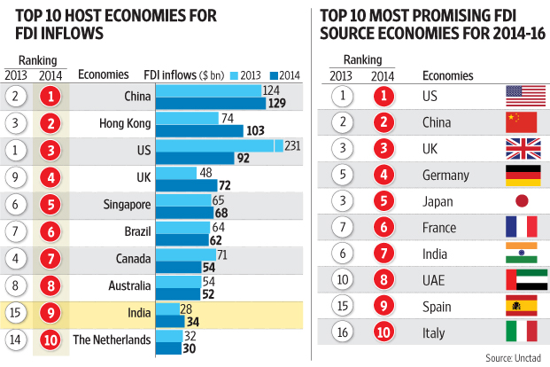

Outline what is meant by Repatriation of Profits
One example of how this influences the transfer of capital between the core and periphery. Here is an example using Apple.

Outline what is meant by Loans and Debt Repayment
Loans

Debt Repayment

One example of how this influences the transfer of capital between the core and periphery. Here is an example using debt owed to the UK.

Outline what is meant by Development Aid
One example of how this influences the transfer of capital between the core and periphery. Here is an example from the Guardian from January 2016.

Outline what is meant by Remittances
One example of how this influences the transfer of capital between the core and periphery. Here is some further information from the World Bank.

