G7 – Globalisation & My Clothes – Fast Fashion!
Why do people often buy more clothes than they need? Can you think of an example?

What does ‘fast fashion’ make people do?

How many new garments are produced each year globally?

There are 8 billion people in the world currently. How many new pairs of clothes does this equate to per person, per year?

What are the issues surrounding the production of cotton?
What has been the impact of cotton production on the Aral Sea? (make sure you check out this video from NASA)

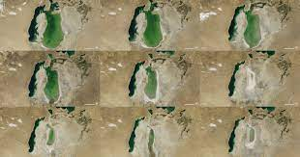

What does Niomi Smart suggest that people can do to reduce their impacts on the environment?

Read the second BBC news report on geographypods. Summarise the three ways in which we can try to be more sustainable in our use of clothing.

