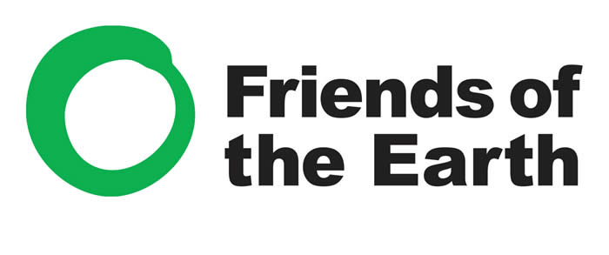
http://www.foei.org

http://www.greenpeace.org/international/en/
Date of formation, country of origin, headquarters and members | Greenpeace was founded in 1971 in Vancouver, Canada. It now has offices in other 40 countries worldwide, but its coordinating body is in Amsterdam. Greenpeace now has nearly 3 million active members worldwide | Friends of the Earth was founded in 1969 in the US and became an international organisation two years later. It is now represented in 76 countries and has a small headquarters in Amsterdam. Friends of the Earth now has over 2 million active members
Mission statement | Greenpeace started as an anti-nuclear and anti-war movement. Greenpeace now states that its goal is to 'ensure the ability of the earth to nurture life in all its diversity'. Its main focuses now are:  - Climate change  - Forests  - Oceans  - Agriculture  - Toxic pollution  - Nuclear disarmament and peace | Friends of the Earth say that they "challenge the current model of economic and corporate globalization, and promote solutions that will help to create environmentally sustainable and socially just societies". Friends of the Earth's main priorities at the moment are:  - Agrofuels  - Climate justice and energy  - Food sovereignty  - Economic justice  - Forests and biodiversity  - Resisting the mining for oil and gas
Fundraising Campaigns | To remain independent (NGO), Greenpeace do not except contributions off governments or corporations, but instead rely on donations from individuals. In 2008 Greenpeace raised close to 200 million euros from its supporters.  Greenpeace's first campaign was sailing a small boat into a remote part of Alaska where the US government was testing nuclear weapons. Since this first campaign the use of ships by Greenpeace has been very important in observing, recording and reporting environmental incidents. Greenpeace currently has three large ships and many more inflatables. Greenpeace's most famous ship was the Rainbow Warrior which was actually sunk in Auckland harbour by French special forces who were unhappy about it recording its nuclear testing in the Southern Pacific Ocean.. | Like Greenpeace, Friends of the Earth get their donations from private individuals. They collect in various ways including:  - Street fundraising  - Door to door fundraising  - Internet  Like many charitable organisations it is possible to make regular monthly contributions to Friends of the Earth via direct debit.  Friends of the Earth and Greenpeace both score very well for how they spend the donations they receive.
Awareness and Publicity | Greenpeace like most current organisations use a growing variety of techniques to contact, inform, educate and communicate with people around the world. Techniques include:  - Website  - Twitter  - Youtube  - Leaflets  - Student resources  - Blogs  - Facebook  - News releases  - Posters and billboards | Friends of the Earth like most current organisations use a growing variety of techniques to contact, inform, educate and communicate with people around the world. Techniques include:  - Website  - Twitter  - Youtube  - Leaflets  - Student resources  - Blogs  - Facebook  - News releases  - Posters and billboards
Examples of charitable work | Greenpeace believes in non-violent protest and has tried numerous techniques to stop environmental damage including:  - Petitions to governments to protect species like tuna  - Boycotts of oil companies causing damage  - Sit in protests against the building of environmentally damaging structures e.g. third runway at Heathrow  - Petition the Brazilian government over its new forest code | Friends of the Earth have numerous ongoing campaigns including:  - Supporting the rights of local communities to fight against damaging and exploitative mining.  - Challenging the influence of big corporations  - Improving water management  - Educating people about problems of agrofuels e.g. palm oil  - Improving access to renewable energy

