|  |
| --- |
| **IGCSE Geography – Economic Development - How does France supply its Energy?** |

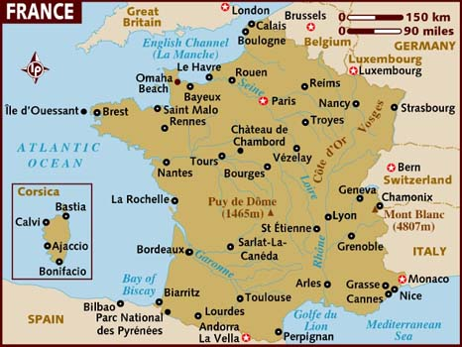

**Energy Mix- France 2024 (describe the graph)**

**Wind Power – St Nazaire**

**How wind power generates electricity:**

**Why St Nazaire ? (use map on geographypods)**

**Outline the scheme (include data):**

**How many TWh produced by wind in France every year?**

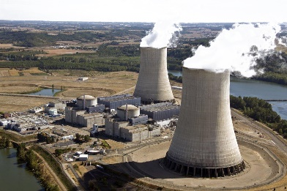

**Nuclear Power – Golfech (Agen)**

**How Nuclear power generates electricity:**

**Why Golfech is a good location:**

**Outline the scheme (include data):**

**How many TWh produced by Nuclear in France every year?**

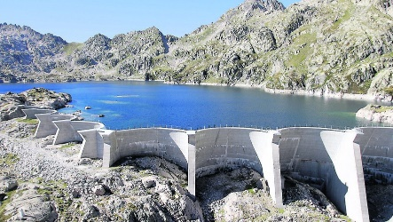

**Hydro Electric Power – Pyrenees**

**How HEP generates electricity:**

**Why the French Pyrenees mountains are a good location:**

**Outline the scheme (include data):**

**How many TWh produced by HEP in France every year?**