|  |
| --- |
| **IGCSE Geography – Economic Development - How does France supply its Energy?** |

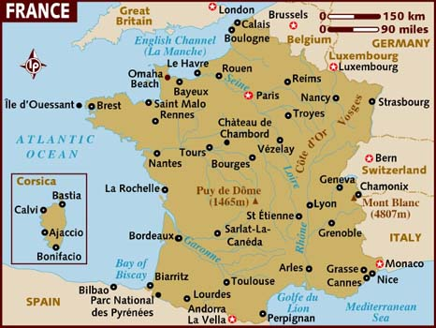

**Energy Mix- France 2023**

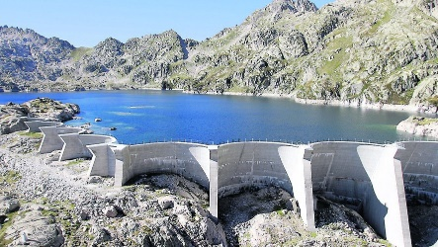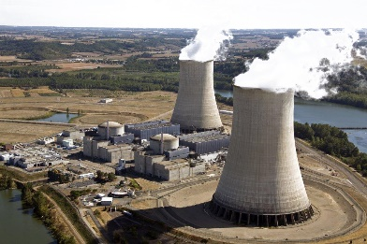

**Wind Power – St Nazaire**

**Hydro Electric Power – Pyrénées**

**Nuclear Power – Golfech (Agen)**