Earthquakes – what causes the ground to shake?
Plot 10 biggest earthquakes on the map below or on your own Pacific centred map
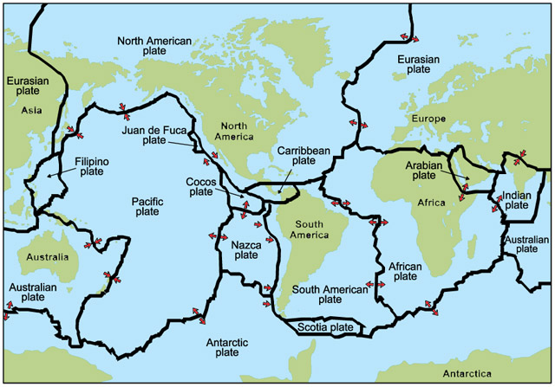
Question 2
Question 3
Copy figure 3.27 on p.123 below

Effects of quakes.

