Factors Affecting Vulnerability
A community's ability to deal with a hazard event.
Demographic Factors
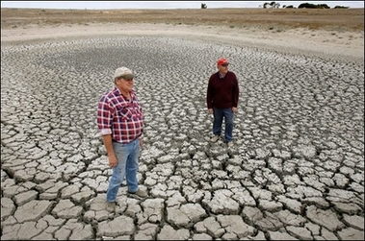
Drought California 2014
Community Preparedness
Socio Economic Factors

