G9 Geography – The Brandt Line – How relevant is it today?
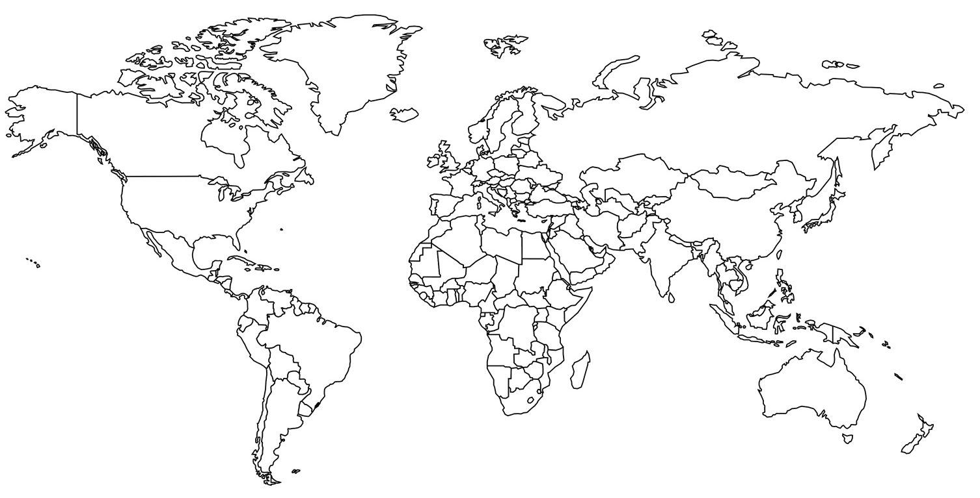
The Brandt Line is a way of visualising the world that highlights the disparities and inequalities between the wealthy North and the poorer global South. It was popularised in 1980 through North-South: A Programme for Survival, a report addressing the problems of international inequality written by a committee led by the former German chancellor, Willy Brandt. The report proposed a set of policies to address problems of global inequality and poverty, and to overcome the political tensions that had emerged between the wealthy, industrialised North and the less economically developed (or underdeveloped) global South. The report included a map of the world divided into North and South by the ‘Brandt Line’, which became one of the most recognisable and influential ways of representing the economic and political divisions of world politics.

Using the 11-minute video on geographypods, write some notes in the space below.

North-South divide still exists | North-South divide does not exist any more

