IGCSE Geography – Constructing an age sex structure for France

- Use the data set below to draw an age sex structure for France in 2016. Use the template on the next page.

MALE POPULATION  in Millions | AGE | FEMALE POPULATION  in Millions
0.03 | 95+ | 0.11
0.16 | 90-94 | 0.44
0.43 | 85-89 | 0.83
0.74 | 80-84 | 1.14
0.96 | 75-79 | 1.23
1.16 | 70-74 | 1.35
1.86 | 65-69 | 2.07
1.93 | 60-64 | 2.11
2.07 | 55-59 | 2.19
2.20 | 50-54 | 2.29
2.22 | 45-49 | 2.27
2.22 | 40-44 | 2.25
2.03 | 35-39 | 2.08
2.01 | 30-34 | 2.10
1.96 | 25-29 | 2.00
1.90 | 20-24 | 1.86
2.09 | 15-19 | 1.99
2.13 | 10-14 | 2.03
2.15 | 5-9 | 2.04
2.02 | 0-4 | 1.94

2) On your pyramid colour
- all the people aged 0-14 red and label them young dependants
- all the people aged 15-59 blue and label them economically active
- all the people aged 60+ yellow and label them old dependants

- Explain what is meant by the three terms
- Young dependants

- Economically active

- Old dependants

- Add the following labels to the most appropriate place on your graph
- Narrow base shows a low birth rate
- Straight sides shows a low death rate
- A baby boom happened when these people were born
- Large number of old dependants

https://www.geographypods.com/2-population-change.html

Population Pyramid Graph – Testing My Skills
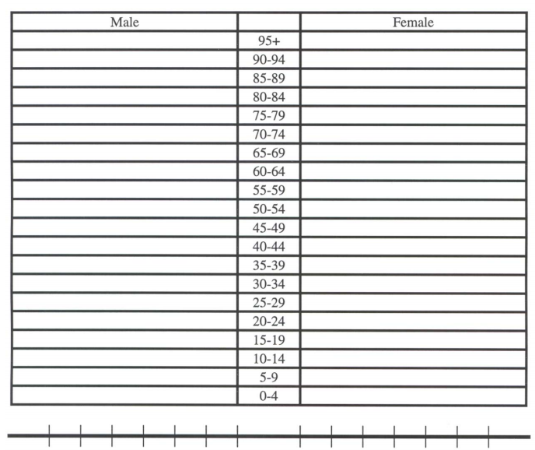

- France has an ageing population. What will France’s government have to spend money on to cater for these people?

https://www.geographypods.com/2-population-change.html

