IGCSE Geography – Indicators of Global Development
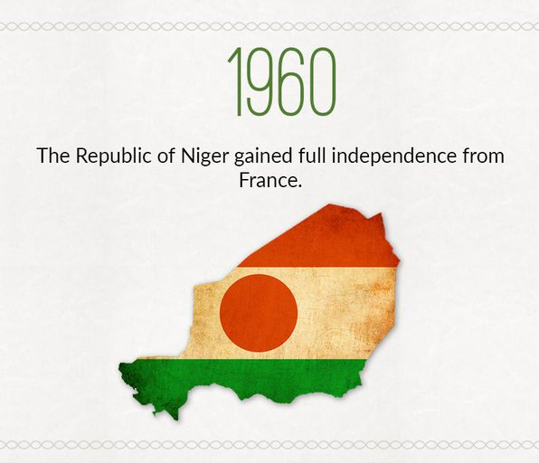
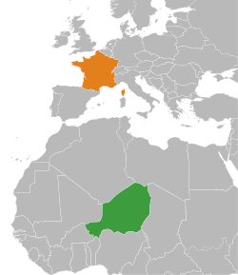
Task 1 – Using the weblink on geographypods, complete the data fact finding mission below.
 | France | Niger
GNI Per Capita ($)
Life Expectancy (yrs)
Literacy Rate (%)

Task 2 – Suggest the reasons for the difference in the GNI figure between France and Niger.

Task 3 – Suggest the reasons for the difference in the life expectancy between France and Niger.

Task 4 – Suggest the reasons for the difference in the literacy rate between France and Niger.

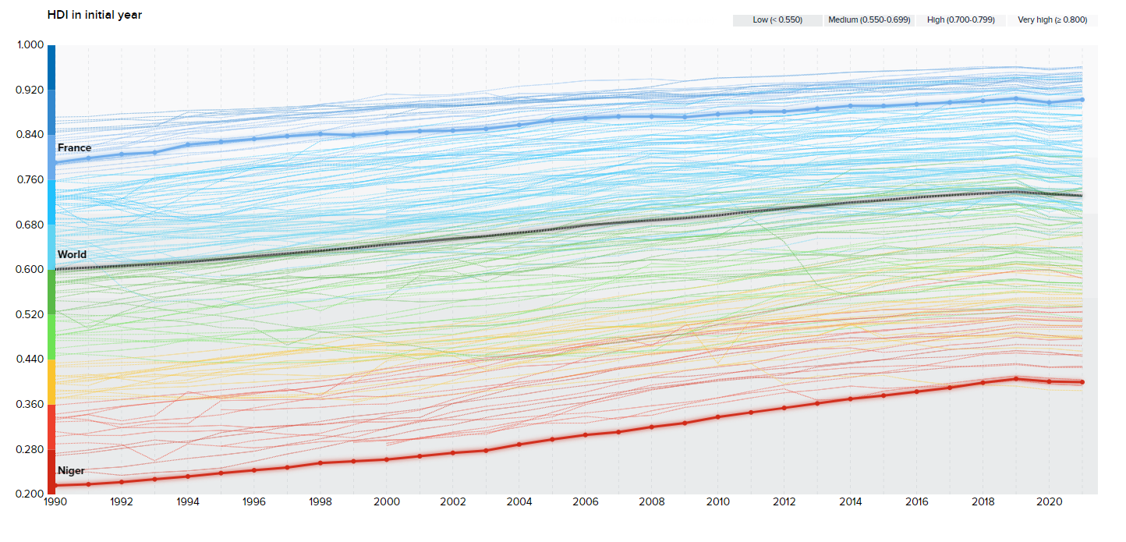
Source – Click this link

Did you know? The Human Development Index (HDI) is a composite statistic (composite index) of life expectancy, education, and per capita income indicators, which are used to rank countries into four tiers of human development. A country scores higher HDI when the lifespan is higher, the education level is higher, and the GDP per capita is higher. The HDI was developed by Pakistani economist, Mahbub ul Haq, for the UNDP. The index is measured on a scale of 0 – 1. (Wikipedia)

Task 5 - Study the graphs that show the HDI growth rate for both Niger and France on the previous page. Compare the development of both Niger and France comparing to the world average.
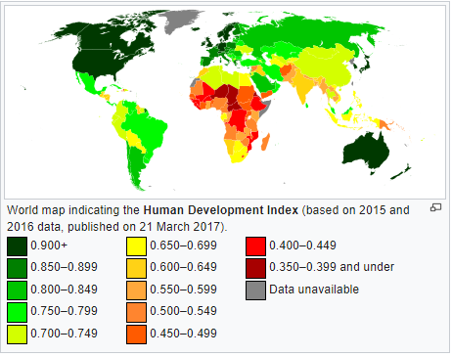

Regional Disparities – France
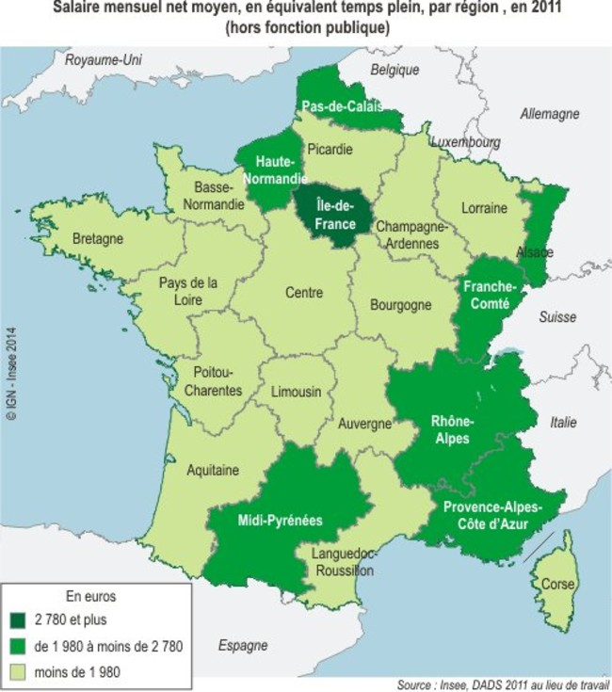
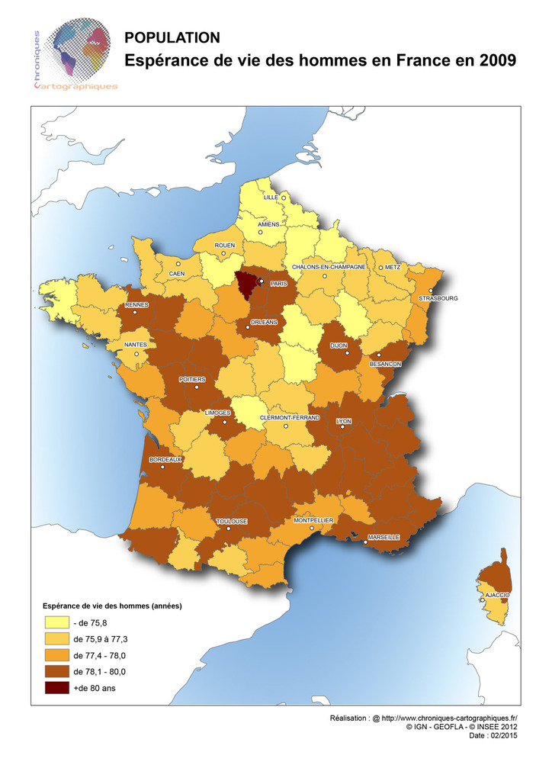

Task 6 – Study the two maps of France above. The one on the left shows average monthly wage per person per region in 2011. The map on the right shows the life expectancy of males in France in 2009.

Describe the patterns on both maps and comment on any links between them.
Suggest the reasons for these regional disparities?

