|  |
| --- |
| **IGCSE Geography – Deserts & Desertification** |

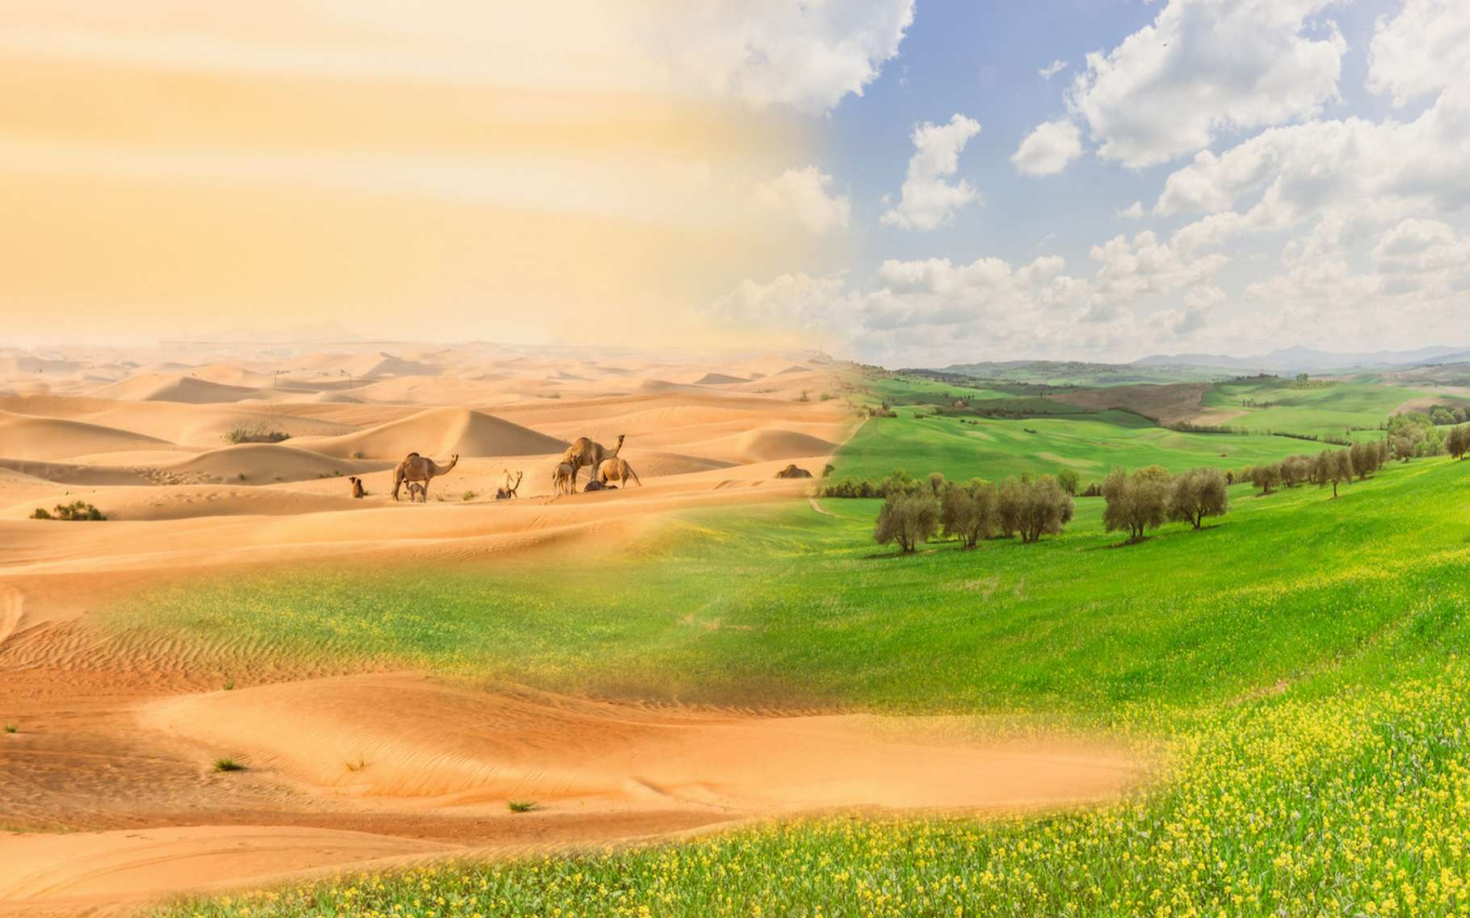

|  |
| --- |
| Watch the first minute of the embedded video on geographypods and explain the processes that lead to desertification. |
|  |

|  |
| --- |
| Explain how the process of desertification can lead to migration. |
|  |



… the video (1.35)

|  |
| --- |
| In the space below, complete your diagram of the cycle of desertification using the link on geographypods. Add the title to the centre of the diagram. |

|  |  |
| --- | --- |
| The effects of desertification. Using the same link as above, complete the table below to show what these figures mean. | |
| 1 billion people… |  |
| In 2014… |  |
| $2 billion … |  |



|  |  |  |
| --- | --- | --- |
| Back to the video. Start at 1.35. Briefly describe the three schemes that can be put into place to combat desertification. | | |
| Scheme 1 - | Scheme 2 - | Scheme 3 - |
|  |  |  |

|  |
| --- |
| Outline the impacts in Niger of these methods on its people and environment. |
|  |

|  |
| --- |
| Using the link coolgeography link on geographypods, complete the map below to show the location of the Sahara Desert, the Sahel, the affected countries and the ‘Great Green Wall’ |

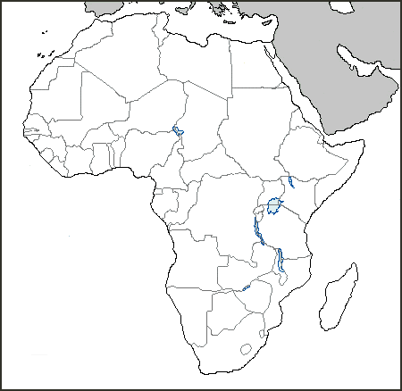

Key

|  |
| --- |
| Using the final two videos on geographypods, describe how the Great Green Wall aims to reduce desertification in the Sahel region of Africa. |
|  |