G7 Everest – The Death Zone 8000 metres +
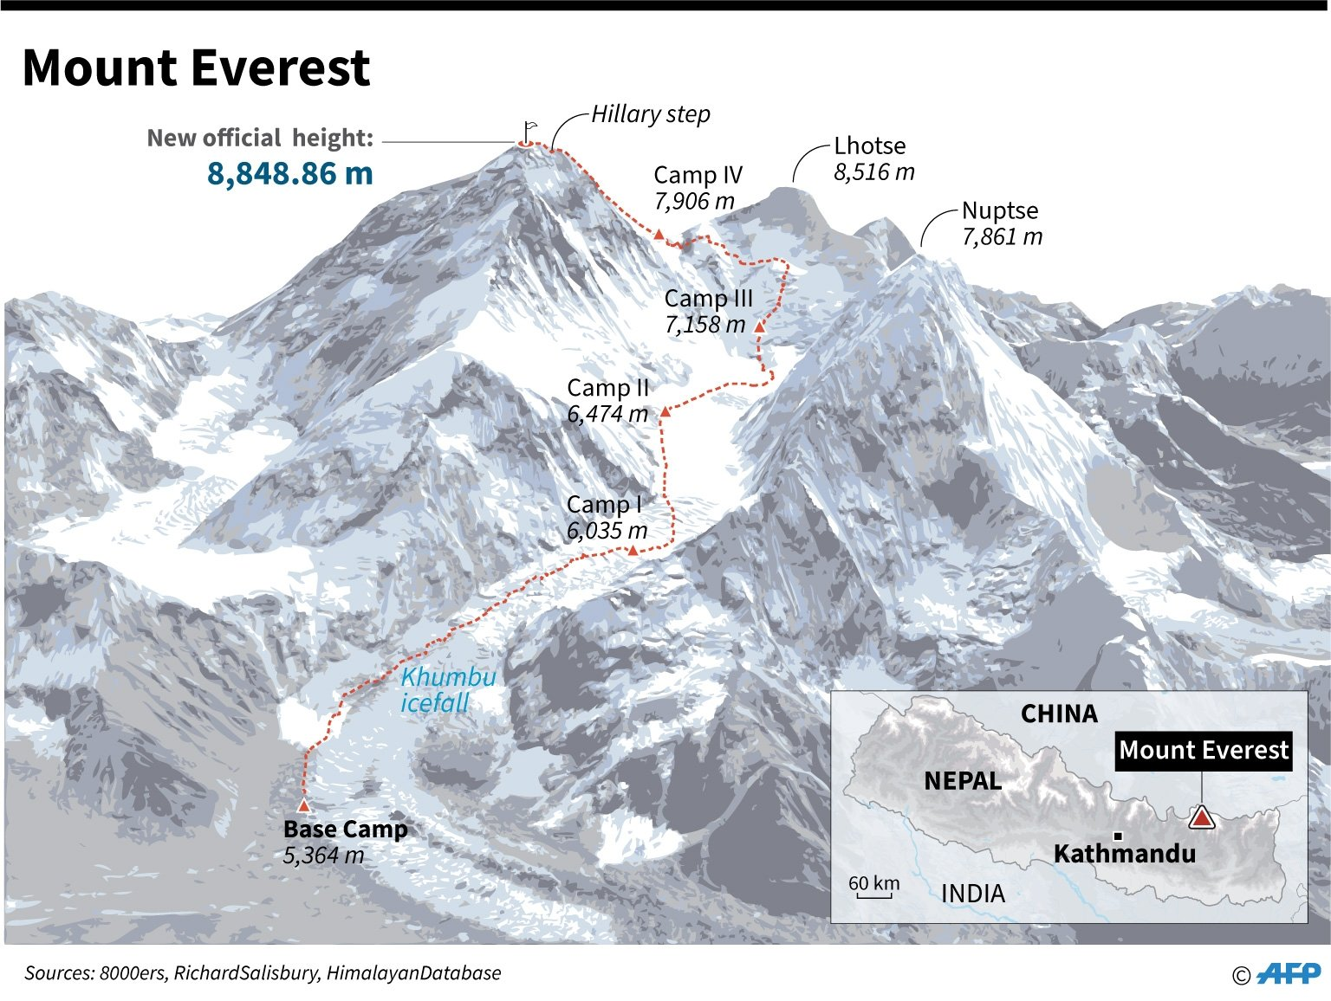
Task 1 – Study the sketch of Everest above. This shows the most famous route up the mountain.

Using the image on geographypods, draw a red line on the sketch above to show the start of the ‘Death Zone at 8000 metres.

Task 2.1 - Why is the altitude above 8000 metres so dangerous to the human body?

Task 2.2 What happens to the human body when exposed to prolonged conditions in the Death Zone?

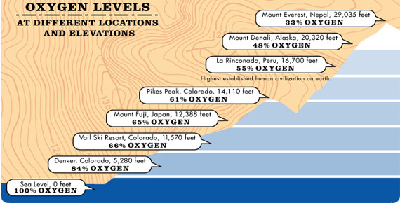

Task 2. 3 How much less oxygen is there on the summit of Mount Fuji than on the summit of Everest?

Task 2. 3 What do climbers have to carry with them on Everest to combat the effects of the Death Zone? Use the image above to help you.

Task 2. 4 – What is the only cure of altitude sickness?

