G7 Everest – The Death Zone 8000 metres +
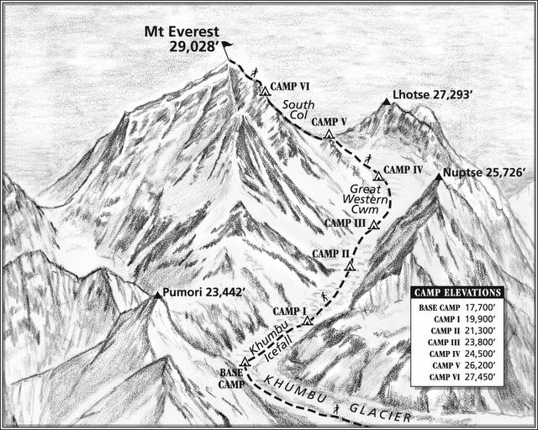
Figure 1 - Source: arleneblum.blogspot.com
Task 1 – Study the sketch of Everest above. This shows the most famous route up the mountain. All the heights are in feet, but you can easily translate that to metres by multiplying by 0.30.

Using the image on geographypods, draw a red line on the sketch above to show the start of the ‘Death Zone at 8000 metres.

Task 2.1 - Why is the altitude above 8000 metres so dangerous to the human body?

Task 2.2 What happens to the human body when exposed to prolonged conditions in the Death Zone?

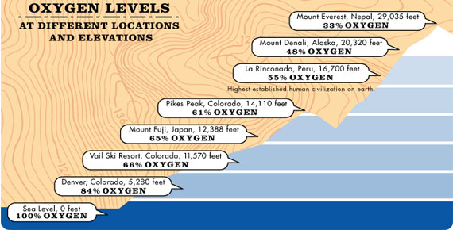

Task 2. 3 What do climbers have to carry with them on Everest to combat the effects of the Death Zone? Use the image above to help you.
