IGCSE Geography – Coral Reef Formation
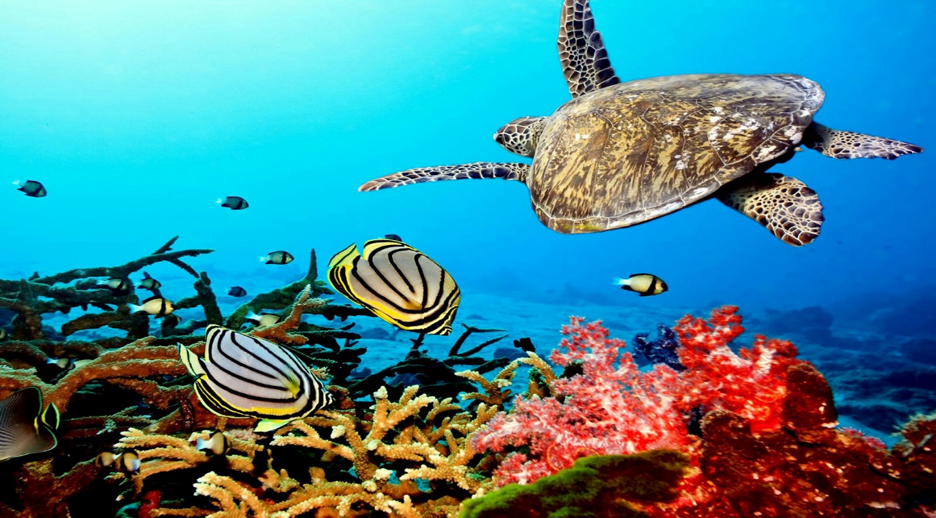

Task 1 – Study the map below of global distribution of coral reefs. In the space below, describe the global distribution of reefs referring to population density. Then use the ‘Ocean Depth’ map on the evidence board on geographypods and compare to the map above. What do you notice?

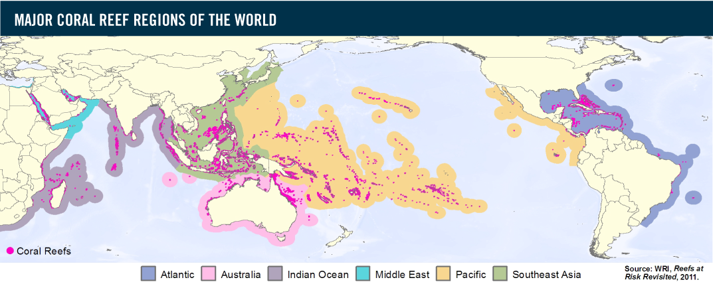

Spatial Distribution

Link to ocean depth

Task 2 – Using this presentation from GATW, note down the key characteristics for coral reefs to form.

Task 3 - The three different types of reefs are shown below. Click on the ‘Three Different Types of Reef’ button in the evidence board on Geography pods and complete the section below. The short video on geographypods will also help you.
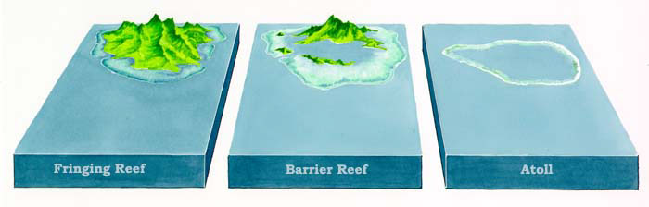
Fringing reefs are formed:

Example location:

Barrier reefs are formed:

Example location:

Atolls are formed:

Example location:

Task 4 – try to think of as many reasons as possible why coral reefs attract people.

Task 5 – Using ‘The Threats’ image on the evidence board on geographypods, annotate the diagram below fully to show the threats to the coral reef by human & physical processes.

