Coral Reefs – IGCSE Geography
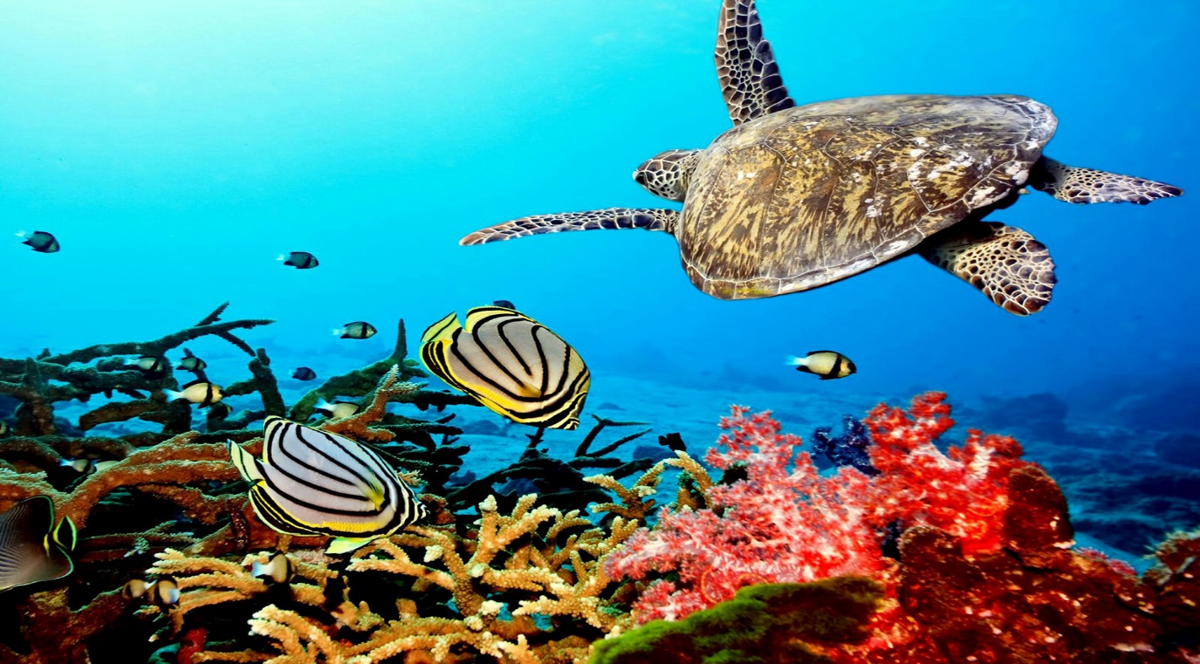

Task 1 – Study the map below of global distribution of coral reefs. In the space below, describe the global distribution of reefs making reference to population density. Then use the ‘Ocean Depth’ map on the evidence board on geographypods and compare to the map above. What do you notice?

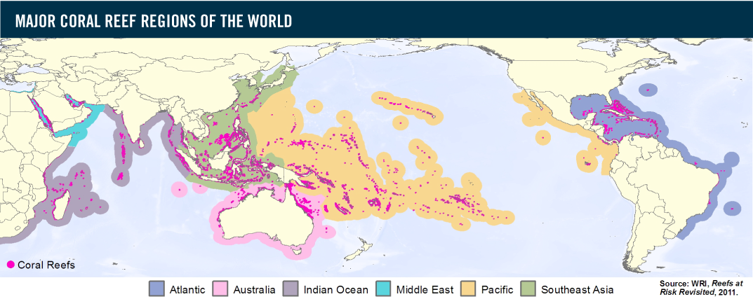

Spatial Distribution

Link to ocean depth

Task 2 – Watch the first 45 seconds of the student created video on geographypods and write in the key physical characteristics for coral reefs to form. Try to relate what you hear to the previous task – think distribution & depth as well as location in relation to equator & tropics.

Then forward the video to 1.22 and watch until 2.12. Add any additional data/detail to your Task 1.

Task 3 - The three different types of reefs are shown below. Click on the ‘Three Different Types of Reef’ button in the evidence board on Geography pods and complete the section below. 2.13 – 2.53 of the student made video on geographypods should help you too.
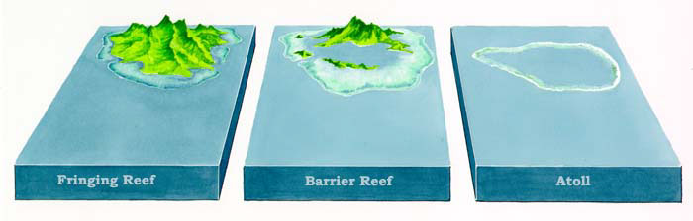
Fringing reefs are formed:

Example location:

Barrier reefs are formed:

Example location:

Atolls are formed:

Example location:

Task 4 – Using 2.13 – 3.34, list down why coral reefs attract human interaction and also include how many people globally live within 100km of a coral reef.

Task 5 – Using ‘The Threats’ image on the evidence board on geographypods, annotate the diagram below fully to show the threats to the coral reef by human & physical processes.

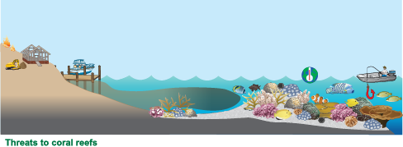

Now check the student made video on geographypods from 3.45 – 4.40 to add anything further that you may have missed.

