S.E.E - Traffic Congestion
IB Geography – Sustainability & the Environment
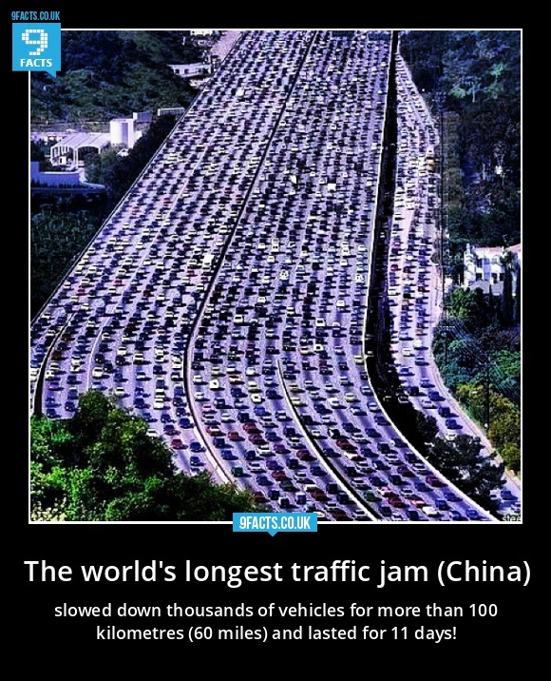
Social Impacts

Environmental Impacts
Economic Impacts

