IGCSE Geography Examples of Coastal Management – Sitges
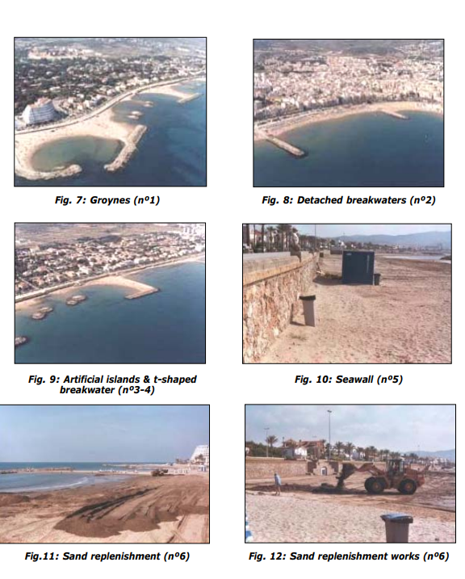

The local government in Sitges has had to use several methods of coastal protection to protect the coastline of Sitges from eroding away. If this was to happen, the town itself (including hotels, bars, and expensive residences) could be lost to the sea. This would be financially & economically catastrophic for the town given its status as one of the premier tourist resorts along this stretch of coastline.
Sitges sits unfortunately on very soft rock, which would be easily erodible by large and destructive waves during winter storms. To combat this erosion and to stop the loss of beach material (sand) by longshore drift, Sitges have put in place several different strategies.

- Groynes – There are series of groynes all along the main beach in Sitges. These rock structures aim to catch sand that would otherwise be transported away by the process of longshore drift. This helps to preserve the beach (massively important for the tourist industry) and helps to build up the level of the beach so that the waves never reach the sea wall.
- Sea wall – A rock and concrete sea wall runs the whole length of the main beach in Sitges. The wall is approximately 2 metres high and aims to refract winter storm destructive waves that hit the coastline. The houses, hotels, and businesses behind are therefore protected. A promenade walk has also been built on top of the sea wall. This is very popular with tourists and people carrying out leisure activities (running, skateboarding etc.)
- T-shaped breakwater & rocks islets – The break water aims to take the power out of strong destructive waves before they hit the shore. The rock islets (fig 6) refract the waves and cause a slowdown in their velocity and an increase in deposition. This builds the beach up behind the islets (as shown in the photos).
- Sand replenishment. Despite all these coastal protection methods, much sand is lost from the beaches in Sitges ever year. This must be topped up before the tourist season starts and so a combination of lorries containing sand and ships blasting sand on to the beach are used to build the level of the beach back up and to cover up the stones and rocks.
