Clouds in the exam – Paper 2
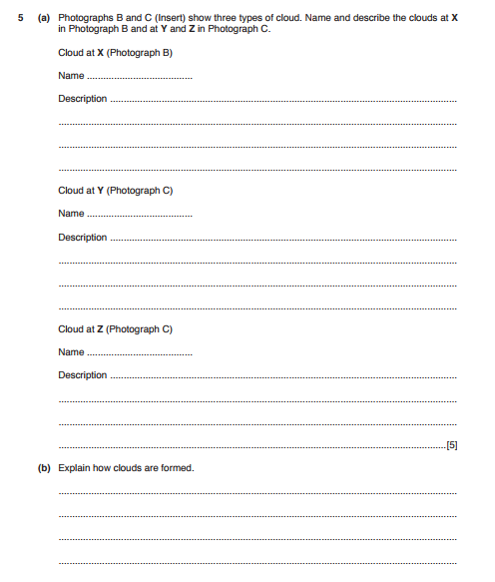

……………………………………………………………………………………………………………………………...
……………………………………………………………………………………………………………………………….
……………………………………………………………………………………………………………………………….
…………………………………………………………………………………………………………………………..(5)

