IGCSE Geography – China - A Country With a Population Decline
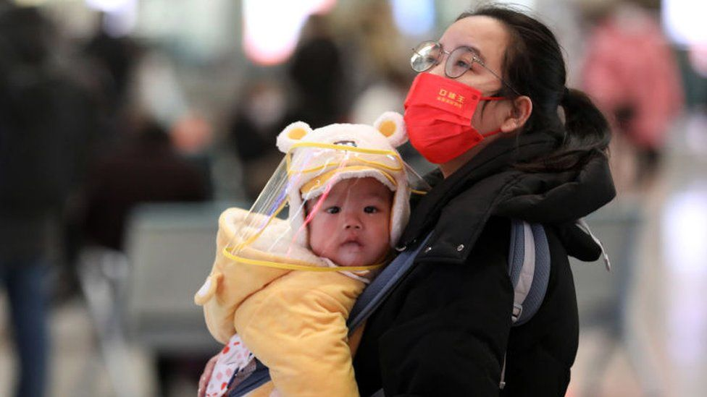
Source: BBC News
- State the year when China last recorded a fall in its total population.

- What was the birth rate in China in 2022?

- How much did the population fall by between 2021 – 2022?
- How many people less is this per day?

- What was the death rate in China in 2022?

- Work out the population growth rate using the data in 2. And 5. Show your working out in the space below.

What would the so called ‘demographic crisis’ lead to?

What could cause a further ‘dragging down the number of new-borns?’

When and how was the famous ‘One Child Policy’ implemented and what did it set out to achieve?
When

How

What

Since the Policy was scrapped in 2016, how have the Chinese government tried to boost the population growth rate?

