IGCSE Geography – Changes in Employment Structure Over Time
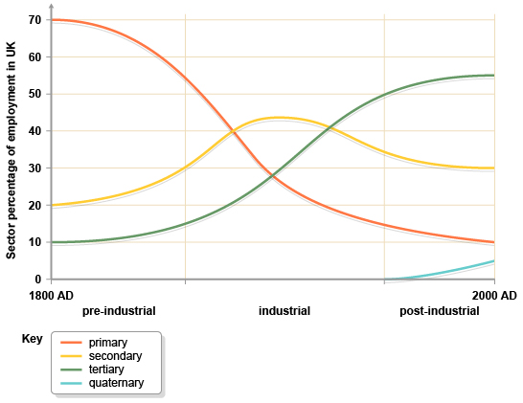

Task – Complete the sentences below using the missing words in the box at the bottom.
Employment structures can also change over time within the same __________.

In the France in 1800 most people would have been employed in the __________ sector. Many people worked on the land and made their living from _________________ and related products.

During the _____________________________, more people were needed to build ships, work in steel making and with textiles. All these jobs are found in the _______________ sector. By 1900 over half of the workers in France were employed in secondary industries.

Since 1900 ___________________ meant that less people were required to work on the land and in industry, as machines could carry out most of the work that people previously did.

Foreign industries also became more competitive and imports such as coal became more affordable. As the availability of coal declined in France, and became more expensive to extract, more coal was _________________. This led to a further decline in primary sector employment in France.

The demand for work increased in schools, _____________ and retail industries. Many people left the rural areas in the search for jobs in the towns and cities like ______________. By the year 2000 over half of the French workforce were employed in ____________ industries and only a small number were employed in primary industries.

This has changed the work that people do, and also where they work. Quaternary industries are a relatively new concept, and it is only recently that they have been added to these figures. However it is becoming an important and growing sector in France as many firms want to carry out research and development for their products e.g. new fuel efficient planes from aircraft manufacturers like ____________.

Primary Country mechanization hospitals tertiary Airbus Toulouse
imported Agriculture secondary industrial revolution

