IGCSE Geography Coasts – Cave – Arch - Stack - Stump (erosion)
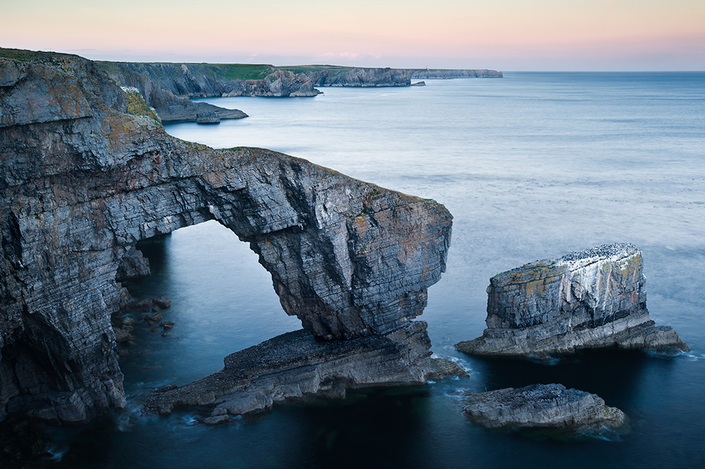
On the photo above, label the cave, arch, stack and stump. Also, label one headland and one bay (link to last piece of work).

After watching the video and studying the diagram and written explanation on the website, draw a ‘mega annotated sketch’ to show the formation of caves, arches, stacks & stumps. Be detailed.

