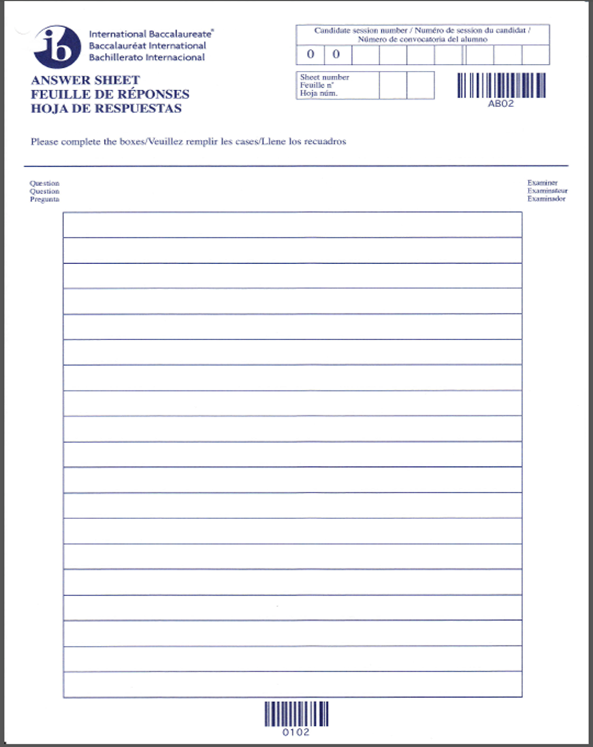
“The negative forces of globalization have conspired to trap DR Congo in the lowest echelons of human and economic development. From this, the country will never recover” – Critically examine this statement.

