IGCSE Geography –Camel Adaptation & Desert Environments
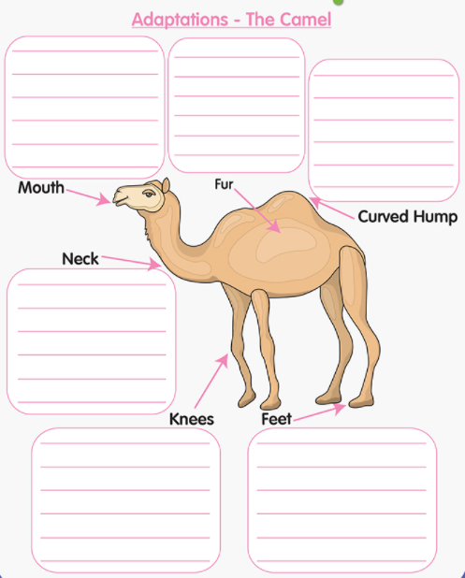
What is the most vital camel adaptation to the hot desert climate, and why?

