IGCSE Geography – Burgess & Hoyt Urban Models
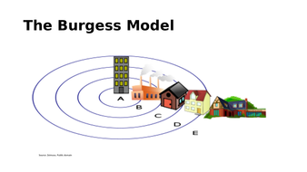

Invented by ________________________

Zone | Name of Zone | Brief Description
A
B
C
D
E

Criticisms of the Burgess Model

The Hoyt Model

Invented by _________________________
Zone | Name of Zone | Brief Description
1
2
3
4
5

Criticisms of the Hoyt Model

