G8 Geography – Brazil’s Indigenous Land is Being Invaded – Vox
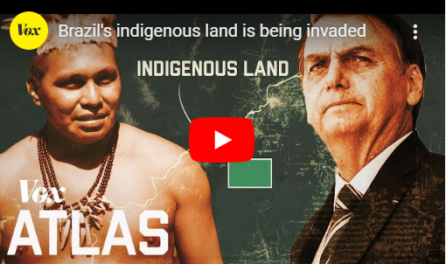

In this section of work, you will be watching the third video of the series that focuses on the impacts of deforestation on the indigenous tribes of the Brazilian rainforest.

You should watch the video all the way through first.

Your task is to identify five key points in the video.

When the video is finished, return to the five sections and take a screen shot and paste in the space below. Then complete a piece of writing to explain what was important.

The first one has been completed for you. See the example below.

Key Point 1 Screenshot | Description
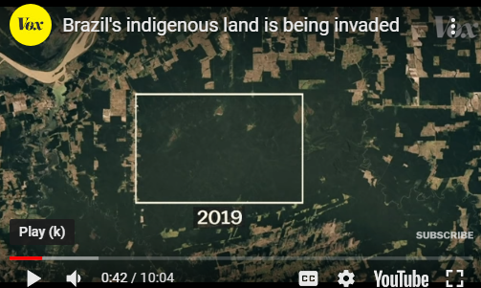 | This screen shot is from 0:42 in the video. It shows the land protected for the Karitiana tribe of Brazil deep in the Amazon rainforest. It was established in 1986 and back then, it was completely surrounded by natural rainforest. Today, it is almost completely surrounded by farms as you can see from the image to the left. The outside world has closed in on this tribe. This is happening across the Amazon rainforest.

Key Point 2 Screenshot | Description

Key Point 3 Screenshot | Description

Key Point 4 Screenshot | Description

Key Point 5 Screenshot | Description

Key Point 6 Screenshot | Description

If you could provide one piece of advice to Jair Bolsonaro (President of Brazil) as a 280 character Tweet, what would you type? Write it out below (1 character = one letter or one space).

