**iGCSE Geography – NIC Urban Models**

Periferia

Favela

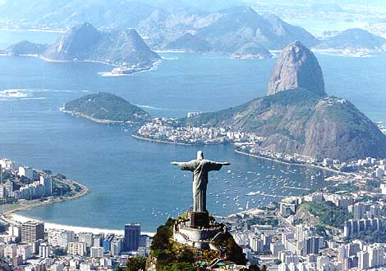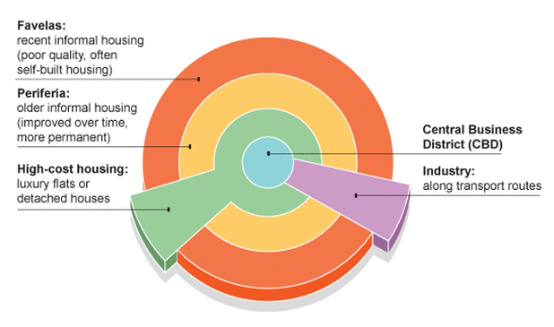

High Cost Housing

Key features that tell you it is this zone.

Key features that tell you it is this zone.

CBD (Central Business District).

Key features that tell you it is this zone.

Key features that tell you it is this zone.