|  |
| --- |
| **G8 – Bottled Water** |

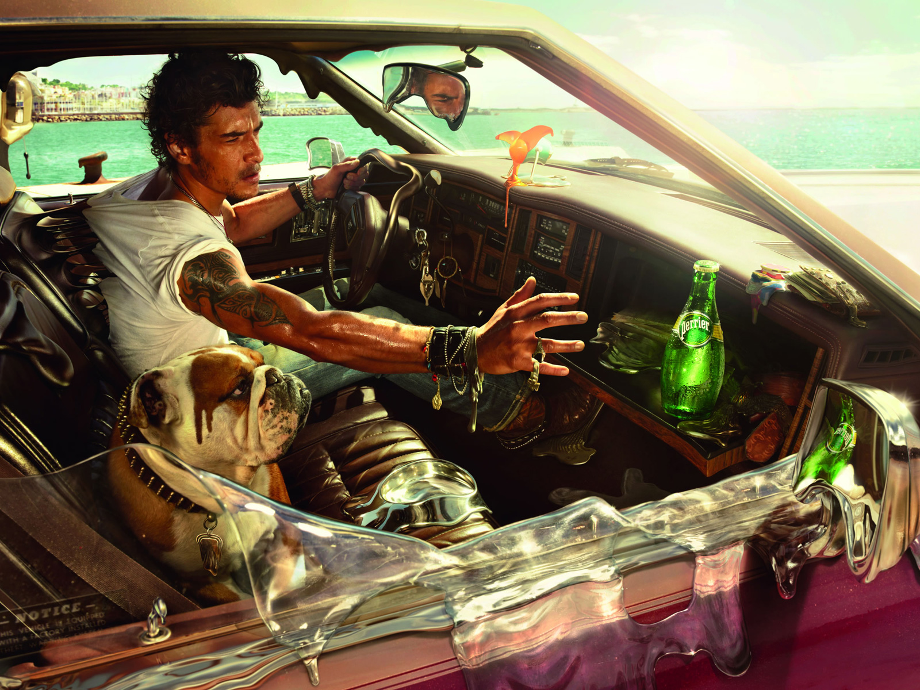

|  |
| --- |
| **Task 1** – Annotate the publicity image above with 5 or more reasons why people drink bottled water. |

|  |
| --- |
| **Task 2**   1. What are the reasons why people buy bottled water? 2. Approximately how many more times expensive is bottled water when compared to tap water? 3. Why and when did bottled water become so fashionable? 4. What is 'manufactured demand' and how was it carried out? 5. How do bottled water companies try to encourage us to purchase their product? 6. Why is disposal of plastic bottles so controversial? 7. What is downcycling? |

|  |
| --- |
| **Where do the plastic bottles end up?** |

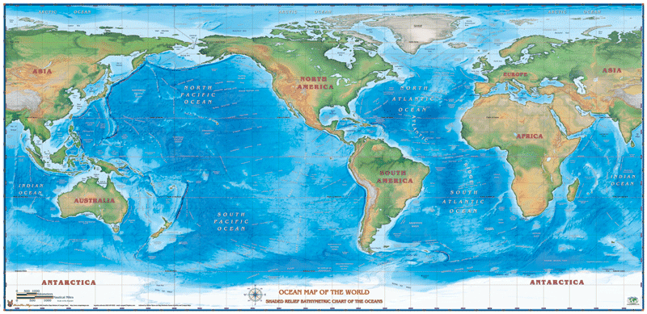

|  |
| --- |
| **Task 3** – Annotate and name the global locations of ocean gyre’s or garbage patches. Then conduct some further research on the issues caused by plastics in the oceans in the space below. |
|  |

|  |
| --- |
| **Task 4** – Make notes on how plastic bottles have been used to bring light to communities in the Philippines. |
|  |

**Video Notes Sheet**

Video 1 – Roller Babies

Video 2 – Powerful Pedalo

Video 3 - Melting

Video 4 – Crazy Volcano

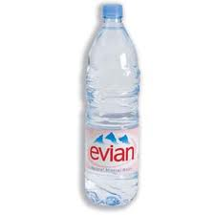

**Can you taste le difference?**

**The Taste Test The real result**

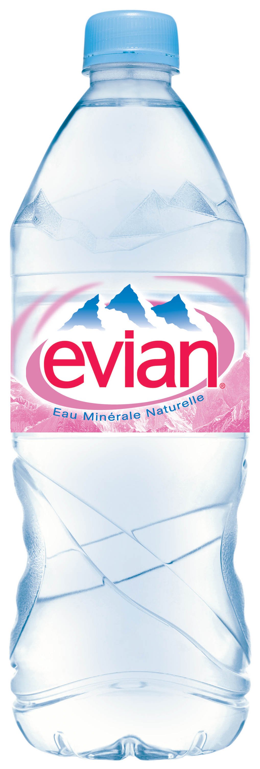

**Evian**

**Vittel**

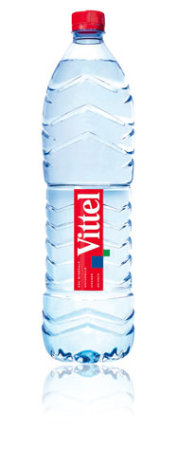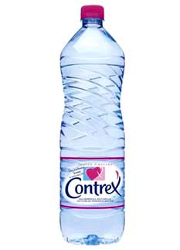

**Contrex**

**IST Tap**

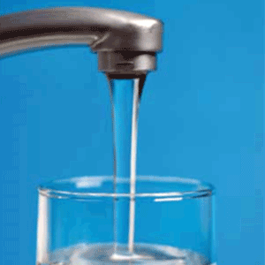

**Score out of 4**

**Research Homework**

Count the number of bottles of water in your recycling bin at the end of the week? How many did you find?

Who drinks bottled water in your household?

On your next visit to your local supermarket, how many different brands of water can you count on the shelves? Are there any brands from outside France?

Feel free to do a taste test with people at home and bring in the results.