IGCSE Geography – Impact of AIDS on Botswana Population Pyramid

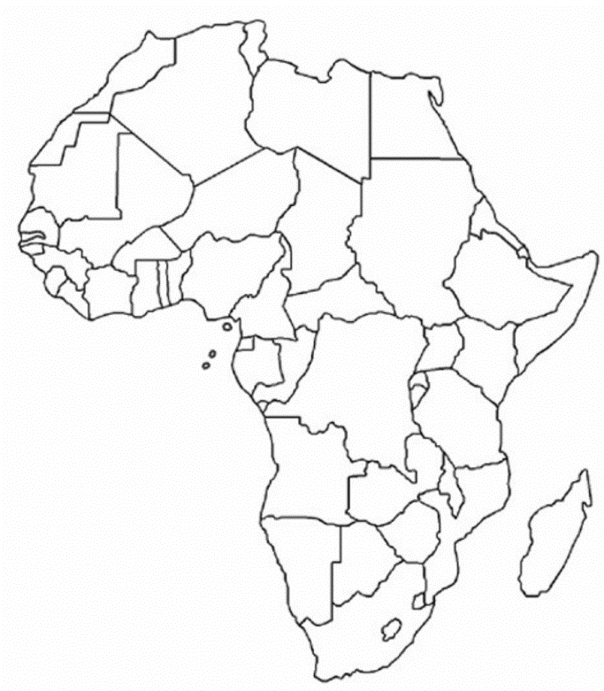
Task 1 – On the map above, shade in Botswana. In the space below, describe the location of the country in Africa.

Task 2 – Complete the data table below by doing a Google search
Botswana AIDS prevalence rate as a %
Key search term: HIV/AIDS in Botswana Wikipedia

Botswana Life Expectancy (in years)

Botswana GDP Per Capita (in $)

Botswana Median Age (in years)

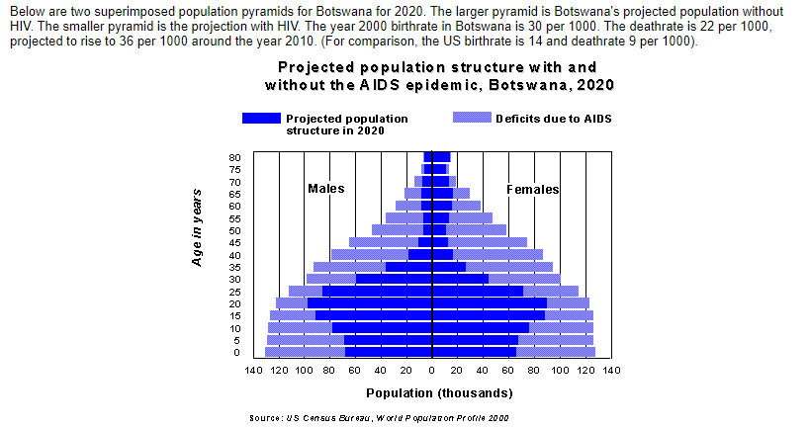

Task 3 - Study the population structure above carefully. Read the description above so that you understand what the different shades of blue mean.

Task 4 - Approximately what % of male children between the ages of 0-5 have died due to the AIDS epidemic?

Task 5 - What is the most likely way that children under the age of 5 contract AIDS?

Task 6 - Explain why those people over the age of 65 in Botswana have been less impacted by the AIDS epidemic.

Task 7 - Explain why those people between the ages of 35 and 50 in Botswana have been more impacted by the AIDS epidemic.

Task 8 - Can you think of any reasons why women in the 25 – 40 age category have been more badly affected by AIDS than men in the same age category?

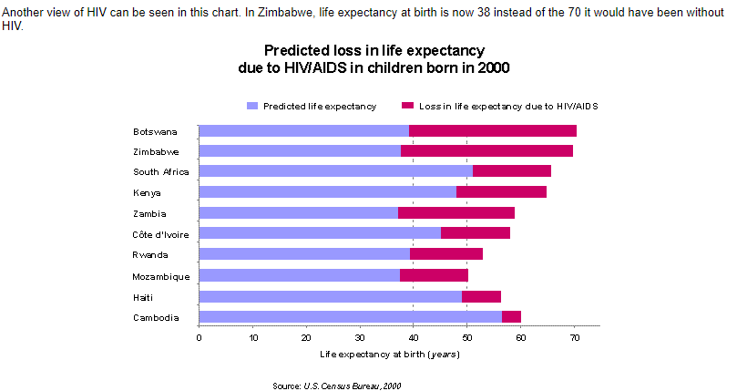
Task 9 - A child born in the year 2000 in Botswana can expect to live to what age:
a. with AIDS
b. without AIDS?

Task 10 - What is the approximate % reduction of life expectancy (due to AIDS) in Zambia?

Task 11 - Which African country on the graph above is expected to see the least impact from AIDS on life expectancy?

In summary:

The population pyramid depicted on page 1 shows the impact of an extremely high HIV prevalence, combined with a lack of anti-retroviral therapies, on the age structure of a population.

This is often referred to as “population chimney”, as high mortality from AIDS in young adulthood leads to the distinctive narrowing in the upper half of the population pyramid.

There is also a narrowing at the base of the pyramid due to the lowering of fertility because of the epidemic (through increased infertility and less women reaching motherhood) and due to increased infant mortality due to mother-child transmission of HIV.

Task 12 - Essay Plan – 7-mark IGCSE Question

Structure:
What is HIV/ AIDS and how is it spread?
Why is the infection rate so high in Botswana?
How does this affect birth and death rates?
How can a high fertility rate contribute towards the spread?
Cultures and Traditions
Explain how the 2020 structure is different if AIDS is taken into consideration.
Concluding statement
14 lines / 14 minutes.

Explain, using examples, how incidences of disease can affect the population structure of a country. (7)

